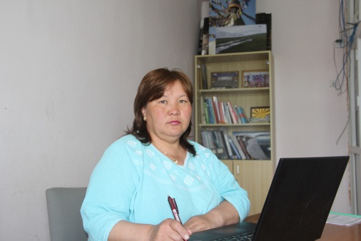

Name: Batbayar Bayarkhuu
Professor
School of Environmental Sciences and Technology
Khovd state University of Mongolia
Khovd, Mongolia

Language(s): Mongolian, Russian, English
Contact: Phone: 976-99438200
E-mail: bayarhuub@yahoo.com
ORCID: https://orcid.org/0000-0002-8559-1430
Potential areas for PhD supervision: Supervising experience:
- Regional study 1 PhD student
- Tourism geography and land management 16 master students

Employment history in last 5 years:
1995 – present Khovd State University of Mongolia

Membership:
Since 2004 Tourism Association of Khovd provinvce, Mongolia
Since 2019 Editorial board of Issue 2. Natural and agricultural sciences Tuva State
University Bulletin, Russia

Education – since bachelor degree:
- PhD in Physical Geography
1999-2004, Russia, Tomsk State University
- MSc in Educational Geography
1995-1997, Mongolian State University of Education, Mongolia
- BSc in Geography teacher
1991-1995, Mongolia, Pedagogical University of Mongolia

Selected recent papers:
- Irekhbayar.J, Amarjargal.A, Altantstetseg.Sh, Bayarkhuu.B, Oyuntsetseg.Ch (2020) “To evaluate antioxidant, cytotoxic, antibacterial activities of aerial parts ethanol extracts from Nepeta sibirica L. grown in Mongolia” page 121-13, http://www.ijrdo.org/index.php/as/article/view/3946
- Battsetseg.D, Lkhagvasuren.Ch, Bayarhuu.B (2019) Survey on soil and soil heavy metal content in the Buyant river basin, Western Mongolia, Vestnik of Tuvan State University, Russia, Issue 2. Natural and agricultural sciences, № 4 (53), 2019
Issue 2. Natural and agricultural sciences, № 4 (53), page 6-16, http://vestnik.tuvsu.ru/vypusk-2/
- Bayarkhuu B. Evaluation of landscape appael for rest and tourism in Khovd province, Mongolia (2013) ISSN 1991-5497. World of science, culture, education.Barnaul, Russia № 1 (38) page 326-328

