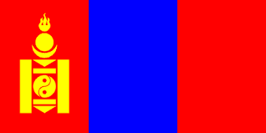
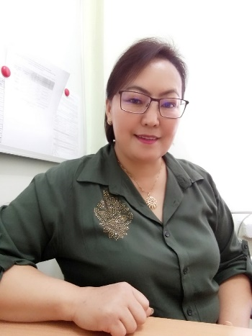

Name: Dagva Unurnasan
Professor
Vice rector of Academic affairs
Khovd State University of Mongolia
Khovd, Mongolia

Language(s): Mongolian, Russian, English
Contact: Phone: 976-99022875
E-mail: onornasan@gmail.com
ORCID: https://orcid.org/0000-0003-0703-5751
Potential areas for PhD supervision: Supervising experience:
- Curriculum study 1 PhD student
- Using ICT in education 11 master students

Employment history in last 5 years:
1997 – present Khovd State University of Mongolia

Membership:
-
Education – since bachelor degree:
- PhD in Education
2009-2015, Mongolian State University of Education
- MSc in Computer Science,
1998-1999, National University of Mongolia
- BSc in Informatics and Mathematics teacher
1993-1997, Mongolian State Pedagogical University

Selected recent papers:

- Unurnasan. D. , Some problems of web based assessment system, (2014), “ICT in education” International conference publication of Unesco;
- Unurnasan. D., On the problem of using e-technology in learning assessment, (2014), // ”Education study” journal of Mongolia №12(108). p. 59-67
- Unurnasan. D., A framework of LMS in Mongolian universities // NITTTR , India. 2018
- Bayarkhuu. B., Unurnasan.D., Summary report of the questionnaire survey for the integration of environmental policy, management, and technology training in doctoral education programs in Mongolia, “Natural conditions, history and culture of western Mongolia and its contiguous regions” IX international conference publication, 2019. p.252-257

