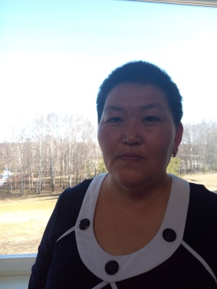
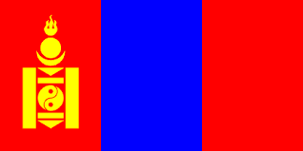

Name: Ayurzana Amarjargal

Professor
School of Environmental Sciences and Technology
Khovd state University of Mongolia
Khovd, Mongolia

Language(s): Mongolian, Russian, English
Contact: Phone: 976-99439775
E-mail: amar731012@yahoo.com
ORCID: https://orcid.org/0000-0001-7350-0012

Potential areas for PhD supervision: Supervising experience:
- Biochemisry 1 PhD student
- Ecological chemistry 15 master students
Employment history in last 5 years:
1996 – present Khovd State University of Mongolia

Membership:
Since 2012 Member of the Chemical Society, Mongolia

Education – since bachelor degree:
- PhD in Organic chemistry
2000-2007, National university of Mongolia, Mongolia,
- MSc in Organic chemistry , National university of Mongolia, Mongolia,
- BSc in Geography teacher
1992-1996, Mongolia, Branch Khovd of National University of Mongolia
Monography.
1. A. Amarjargal, S.Shatar ”Chemical research of essential oil of some useful plants of Govi-Altai” . Ulaanbaatar, Mongolia (2005). (co-author), ISBN 978-99962-2-655-7
Selected recent papers:
- Ts.Tsuruoka, S.Shatar, Sh.Altantsetseg, A.Amarjargal The essential oil Mongolian Nepeta sibirica: a singlе component and its biological activities Journal . Essential Oil. Res. Vol 24, No 6, December 2012, р.555-559.ISSN 1041-2905, DOI: 10.1080/10412905.2012.729925
- Irekhbayar.J, Amarjargal.A, Altantstetseg.Sh, Bayarkhuu.B, Oyuntsetseg.Ch (2020) “To evaluate antioxidant, cytotoxic, antibacterial activities of aerial parts ethanol extracts from Nepeta sibirica L. grown in Mongolia” page 121-131, http://www.ijrdo.org/index.php/as/article/view/3946
3. A.Amarjargal, B.Bayarkhuu, Sh Altantsetseg Study of biochemicial composition of Siberian catmint of the territory of the Khovd University, Mongolia Вестник Тувинского государственного университета Выпуск 2. Естественные и сельскохозяйственные науки, №4(53), 2019, p.17-28 ISSN2077-5326, doi 10.24411/2077-5326-2019-10016
4.N. Jabzmaa, Sh Altantsetseg, Shatar. S, Amarjargal A Chemicial compositions of essential oils from two Artemisia species used in Mongolian traditional medicine Mongolian journal of Chemistry 18(44), 2017, р. 48-51, https://doi.org/10.5564/mjc.v18i44.881

