REPORT
on the use of equipment purchased
by V. N. Karazin Kharkiv National University, UKRAINE
under the INTENSE project

Conducted in-depth survey of end-users and the institutional contexts helped us not only identify gaps in the existed curricula and develop the list of e-courses to be developed by KKNU under the project, but also identify the equipment that would suit our students’ and teachers’ current needs.

Thus, in the framework of the ERASMUS+ project “INTEGRATED DOCTORAL PROGRAM FOR ENVIRONMENTAL POLICY, MANAGEMENT AND TECHNOLOGY – INTENSE” V.N. Karzin Kharkiv National University has opened a new computer class and purchased 18 computers (specification: R-LINE computer: Intel Pentium G4400/ Gigabyte GA-H110M-S2H/DDR4 8GB Adata/ HDD 1TB Toshiba DT01ACA100/ DVD-RW LG GH24NSD1/ ATX Gamemax MT507 450Bт, Monitor: 23,8’’ Acer SA240YBMID (UM.QS0EE.005), Keyboard: Genius KM-125 USB, Computer mouse) and all necessary Windows software.

The equipment is used in the educational process: for e-learning, development of new courses, training of PhD students.

Also PhD students can use the equipment for research: creation and updating of databases, cartographic purposes, search, analysis and treatment of data and information during writing of their PhD theses.

KKNU team regularly uses the equipment for communication, presentation and dissemination purposes: on-line working meetings, workshops, conferences etc.

New computer classroom is located at address:
Room 476
Karazin Institute of Environmental Sciences
V. N. Karazin Kharkiv National University
Svobody sq., 6 Kharkiv 61022
UKRAINE
According to rules of visualization, all equipment has ERASMUS+ stickers.

In addition, KKNU has purchased four Lenovo notebooks (Lenovo V130-15 (81HNS00H00)) which are necessary for everyday work of teachers and project team for assuring smooth functioning of the INTENSE School.
Notebooks are used in the educational process: for making presentations during classes as well as for training of PhD students. Also notebooks can be used for field training (e.g. during summer schools) and field research (e.g. for field trips for collection and treatment of data). In addition, four notebooks are used for dissemination activity (making presentations on conferences and seminars).

Notebooks are located at address:
Rooms 4-71, 4-75, 4-77 and 4-79
Karazin Institute of Environmental Sciences
V. N. Karazin Kharkiv National University
Svobody sq., 6 Kharkiv 61022
UKRAINE
According to rules of visualization, all equipment has ERASMUS+ stickers.

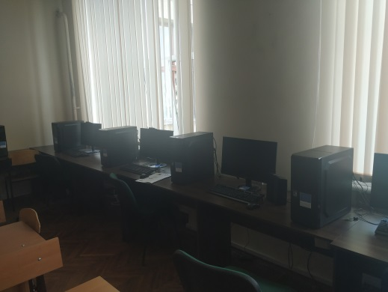
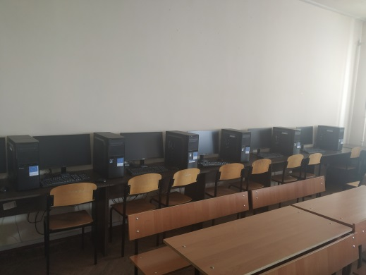

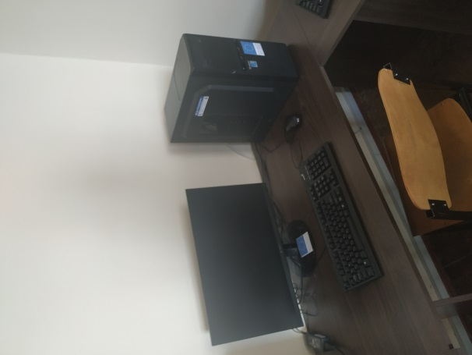

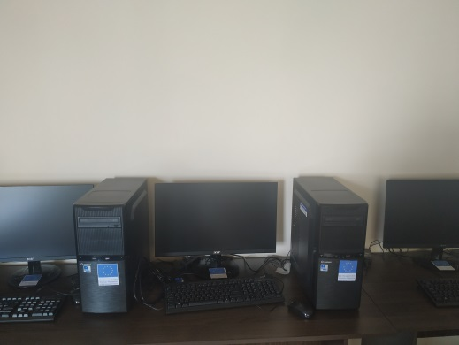

Computer classroom (18 computers)
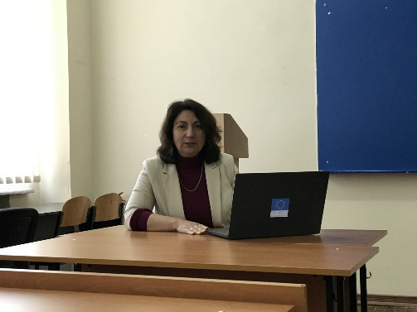
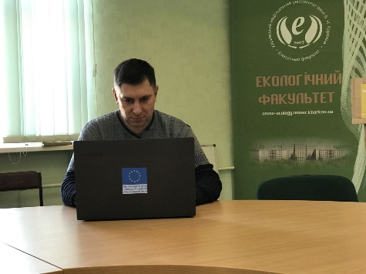
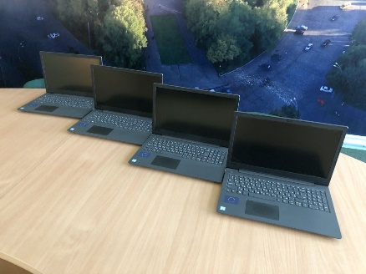

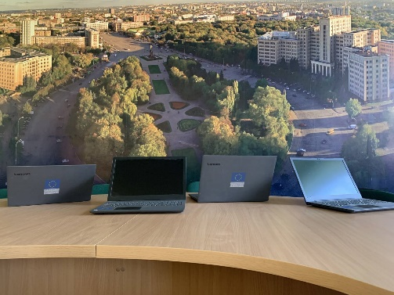
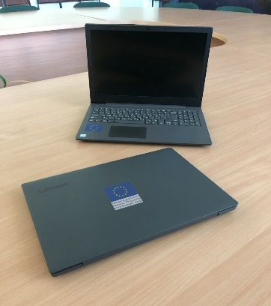
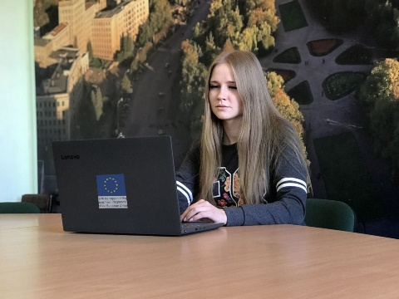

Four Lenovo notebooks
№ | Title and description | Photo
1 | R-LINE computer:  Intel Pentium G4400/ Gigabyte GA-H110M-S2H/DDR4 8GB Adata/ HDD 1TB Toshiba DT01ACA100/ DVD-RW LG GH24NSD1/ ATX Gamemax MT507 450Bт | 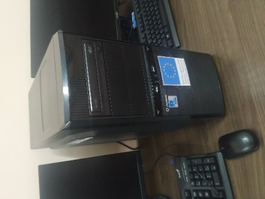  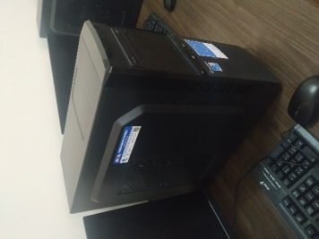
2 | Monitor:  23,8’’ Acer SA240YBMID (UM.QS0EE.005), | 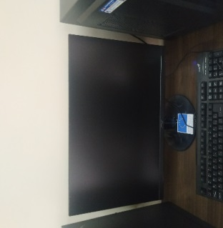
3 | Keyboard:  Genius KM-125 USB  Computer mouse | 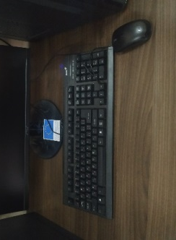
4 | Lenovo notebook  Lenovo V130-15 (81HNS00H00) | 