Quality Assessment Report

Course: Models for Environmental Risk Assessment

Outline:
- General information
- Assessment objectives
- Questionnaire for students and its results
- Questionnaire for a teacher and conclusions

1. General information

Credits | 3 ECTS (optional course), 30 in-class hours
Level | PhD students
Host institution | Karazin Institute of Environmental Sciences, V.N. Karazin Kharkiv National University, Ukraine
E-link: | https://dist.karazin.ua/  http://intense.network,  http://ecology.karazin.ua/mizhnarodna-dijalnist/intense-integrated-doctora/
Authors: | Alla Nekos (course coordinator)  Inna Bodak

The main course objective is to introduce the students to the key elements of risk assessment methodology, and to give a better understanding of how environmental risk is defined, as well as how risks may be evaluated and managed. In particular, the course will discuss the core concepts, principles and stages of risk assessment, providing students with the ability to identify, explain, and make decisions about risks to public health and nature. The students will learn how risk analysis is done, how it is interpreted, and how it influences regulatory decision-making.
In general, this course focuses on applying modern concepts to diverse risk assessment issues, as well as finding the possible ways of improving the effectiveness of current risk assessment practices.

2. Assessment objectives

The assessment was conducted in order to collect the students’ comments and feedback about the course, compare them to the students’ actual achievements, and carefully analyze obtained results to see if the pilot approbation of the course in 2019-2020 and 2020-2021 academic years was positive as well as to see some other changes should be made to the course content or teaching methodology.

Assessment was made by using Google forms as a tool.

3. Questionnaire for students and its results

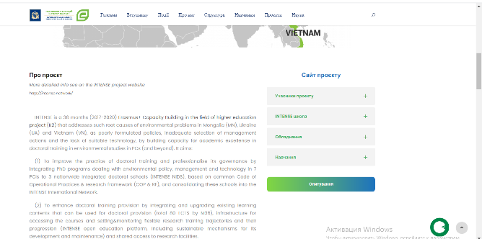
The questionnaire for the students was posted on the web-site of the Karazin Institute of Environmental Sciences (http://ecology.karazin.ua/mizhnarodna-dijalnist/intense-integrated-doctora/intense-opituvannja/).

It consists of two sections:
Section A – Overall evaluation of the course.
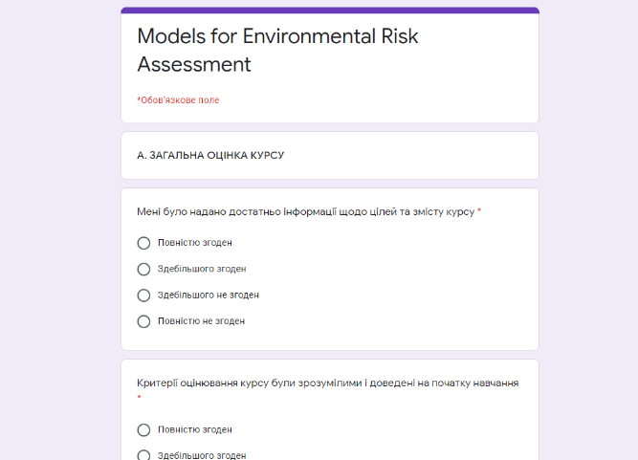
Section B – Evaluation of the course content.

The questionnaire was anonymous.

Total number of questions – 13.

The assessment was made in February-March 2021.

Number of students – 5.

Below the analysis of the feed-back is presented:

Sections A - – Overall evaluation of the course
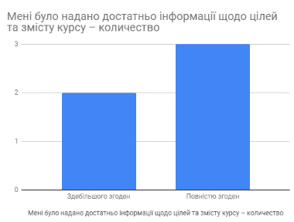
1. I was provided with sufficient information about the aims and the content of the course:
- Absolutely agree –60%
- Mostly agree – 40%
- Mostly disagree – 0%
- Absolutely disagree – 0%

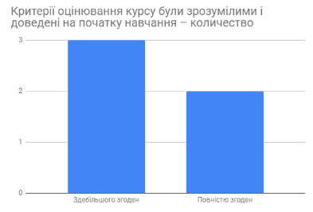
2. Assessment criteria were clear and were presented by teacher at the beginning of the course:
- Absolutely agree –40%
- Mostly agree – 60%
- Mostly disagree – 0%
- Absolutely disagree – 0%

3. Assess the level of complexity of this course:
- The course was too complicated; my personal background knowledge was not sufficient to understand it – 0%
- The course was rather difficult, but well developed, allowing me to study it at the required level – 80%
- The course was quite easy, though some themes and the way they were taught aroused my interest – 20%
- The course was elementary; most information was familiar to me – 0%

4. Various forms and methods of teaching were used in this course:
- Absolutely agree – 60%
- Mostly agree – 40%
- Mostly disagree – 0%
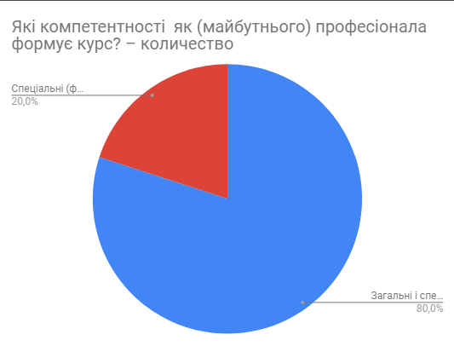
- Absolutely disagree – 0%

5. What competences does the course develop?
- Common – 0 %
- Professional – 20 %
- Common and professional together – 80 %

6. What is your overall assessment of the course?
- Excellent – 40%
- Good – 60%
- Not good enough – 0%
- Satisfactory – 0%
Section B – Evaluation of the course content
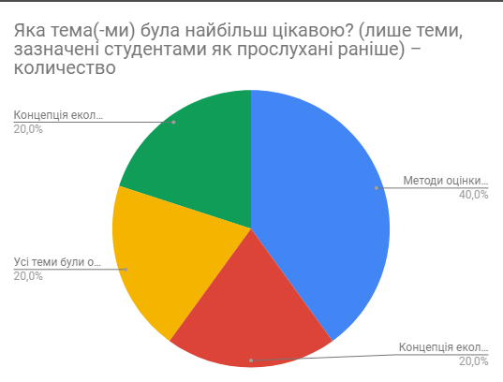
1. What topic was most interesting for you?
- Environmental risk concepts – 20 %
- Concept and criteria of risk acceptance – 20 %
- Risk assessment methods – 40 %
- All topics were interesting – 20 %

2. What topic was most difficult for you?
- Environmental risk concepts – 40 %
- Concept and criteria of risk acceptance – 20 %
- Risk assessment methods – 40 %
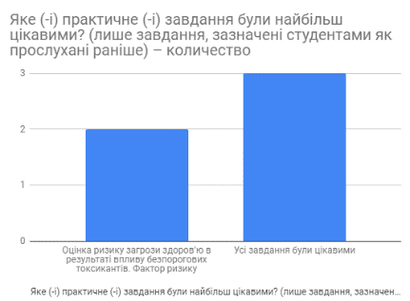
3. What practical works / seminars were the most interesting for you?
- All tasks were interesting – 60 %
- Assessing of health risk in case of exposure to non-threshold chemicals. Slope factor – 40 %
- Assessing of health risk in case of exposure to chemicals having a threshold dose – 0 %

4. Which tools and learning materials presented in the Moodle do you consider most useful for you in the process of blended learning (concerning this course)?
- PowerPoint Presentations – 20%
- Video lectures – 0%
- Preparation materials for seminars and practical assignments – 20%
- Examples of calculations – 10%
- Tests – 0%
- Reference materials (links to official normative documents and additional literature) – 0%
- Questions for self-control – 10%
- All of the above-mentioned – 40%

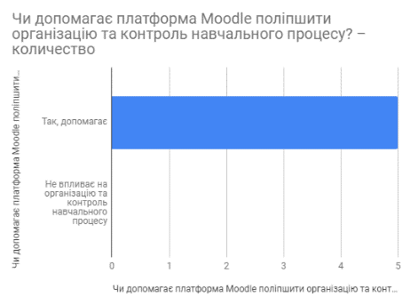
5. Does the Moodle platform help to improve the organization and control of the learning process?
- Yes, it does – 100%
- It does not affect the organization and control of the educational process – 0%
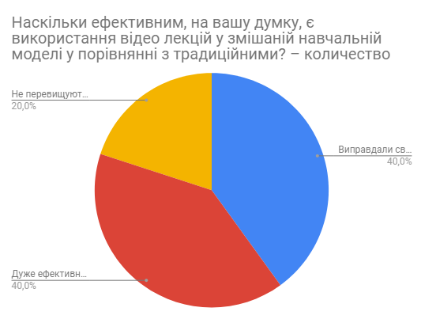
6. How effective do you think the use of video lectures in a blended learning model is as compared to traditional ones?
- Very effective, as it allows listening to them at your own pace and several times (if necessary) – 40%
- Proved to be an effective substitute for traditional lectures – 40%
- Do not exceed traditional lectures in their efficiency – 20%

7. Does this course require improvement? If so, in what part?
- Yes, it does – 20% (but no other comments)
- No, it does not – 80%

4. Questionnaire for a teacher and conclusions

The questionnaire for the teacher/course developer (Inna Bodak) consisted of 9 questions and was filled out after receiving and analyzing student’s feedback.

1. What is your overall assessment of the course?
- Excellent
- Good
- Not good enough
- Satisfactory

2. Was the course taught in 2019-2020 academic year?
- Yes
- No

If ‘yes”:
- What modifications were introduced into the course for 2020-2021 academic year?
During the second year of this course approbation I have included one more topic and improved preparation materials for practical assignments.

- Does the revised course contribute to more efficient process of acquiring the competencies provided by the Curriculum?
- Yes, it does
- Yes, but not to a large extent
- Efficiency is the same

3. How do you assess the impact of the online module for self-study on the process of teaching students this new course?
- There were significant advantages, including increased interest in the course and the quality of learning in general compared to traditional courses
- Despite general interest in the course the students did not show due responsibility while studying online module
- The students studied online module with greater interest
- Had no impact (did not differ significantly from traditional courses)

4. How do you assess the distribution of the number of hours: lectures / practice / seminars / self-study?
- Good balance
- No balance
If “no balance”, please, explain:
___________________________________________________________________________
___________________________________________________________________________

5. What methodological aspects of the new course do you find most useful?
- Blended learning model
- Support for individual learning paths
- Availability of feedback from students during the course
- Possibilities of using Moodle tools

6. Which tools and learning materials presented in the Moodle were mostly demanded in the process of blended learning (concerning this course)?
- PowerPoint Presentations
- Video lectures
- Preparation materials for seminars and practical assignments
- Examples of calculations
- Tests
- Reference materials (links to official normative documents and additional literature)

7. Does the Moodle platform help to improve the organization and control of the learning process?
- Yes, it does
- It does not affect the organization and control of the educational process

8. How effective do you think the use of video lectures in a hybrid learning model is as compared to traditional ones?
- Very effective, as it allowed students to listen to them at their own pace and several times (if necessary)
- Proved to be an effective substitute for traditional lectures
- Do not exceed traditional lectures in their efficiency, but require special conditions and equipment to produce high quality videos

9. Does this course require improvement? If so, in what part?
- Yes, it does.
- No, it does not.
If “yes’, please, give details:
___________________________________________________________________________
___________________________________________________________________________

Conclusions:
The course “Models for Environmental Risk Assessment” has received very positive feedbacks from students: overall evaluations: 40 % - Excellent, 60 % - Good; 20 % students liked all topics; and 40 % considered all used tools as learning materials as very useful; 80 % has indicated that the course was rather difficult, but well developed, allowing to study it at the required level.

The major part of the students (80%) specified that the course did not require any improvements and only 20 % of students recommended to improve the course, however they did not provide detailed comments what topics/methods/tools should be modified.

