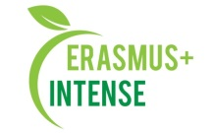
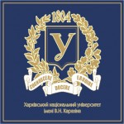
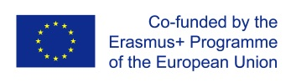

Courses developed by V.N. Karazin Kharkiv National University
in the framework of ERASMUS+ project
“Integrated Doctoral Program for Environmental Policy, Management and Technology – INTENSE”
## | Name of the course | ECTS | Name of the program | Course level | Course type | Accreditation level | Review | Students involved/taught | Confirming documents
1 | Philosophy of Science | 5 | 101 – Earth Sciences | PhD | Obligatory | University | 2 UA reviews  +  1 EU review is expected | 6 | Education and science program “Earth sciences”  Curricula for 2019-2020 and 2020-2021 (full time and part-time)  Working program and syllabus  Interim accreditation documents for course piloting for 2019-2020? 2020-2021 academic years  Certification of e-courses - KKNU MOODLE platform*  All docs are available in http://intense.network/e-modules/
2 | Science Methodology |  |  | PhD | Obligatory
3 | Natural Resource Science | 6 |  | PhD | Obligatory |  |  | 7
4 | Environmental Policy and Management | 3 |  | PhD | Elective |  |  | 6
5 | Geomatics and Modelling | 3 |  | PhD | Elective |  |  | 12
6 | Practice Learning in University Teaching | 3 |  | PhD | Elective |  |  | 10
7 | Environmental Projects Development and Management | 3 |  | PhD and MSc | Elective |  |  | 4
8 | Models for Environmental Risk Assessment | 3 |  | PhD | Elective |  |  | 5
9 | Sustainable Development | 3 |  | PhD | Elective |  |  | 9
10 | Environmental Management Practices | 3 |  | PhD and MSc | Elective |  |  | 8
* Certificates are available for Philosophy of Science and Science Methodology. Other courses will be submitted for certification in 2021-2022 academic year.

