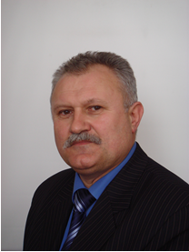 |  | Professor Ljubomyr TSARYK  Department of Geoecology and methods of teaching environmental sciences. Ternopil Volodymyr Hnatiuk National Pedagogical University, Ukraine  Languages: Ukrainian, Russian, German  Contact: tsarykl55@gmail.com +38-096-500-44-27 |  |  |  | 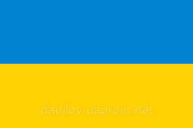
ORCID: |  | https://orcid.org/0000-0003-0944-1905
Potential areas for PhD supervision: |  |  |  |  | Supervising experience:
- Conservation of landscape and biological diversity,  - Protected area and the formation of ecological networks  - Recreational nature management  - Optimization of nature management,  - Environmental impact assessment  - Environmental education |  |  |  |  | 10 PhD students  2-3 master students (every year)
Employment history in last 5 years
1987 – present |  |  |  | Ternopil Volodymyr Hnatiuk National Pedagogical University, Ukraine
Membership of professional association: |  | 2018  2017  1986 | Member of the Member of the Shevchenko Scientific Societ  Society of Local Historians of Ukraine  Member of the Ukrainian Geographical Union
Education – since bachelor degree:
2011 | Full Professor (Geographic)
2010 | Habilitation (Doctor of Sciences – eqv. 2nd PhD) specialized in Constructive Geography and Balanced Use of Natural Resources
1988 | Habilitation (PhD), specialized in Economic and Social geography
1982 | Graduation (Dipl.Geogr.) in Lomonosov Moscow State University, Moscow
Selected recent papers:
- L. Tsaryk, L. Yankovs'ka, P. Tsaryk, S. Novyts'ka, I. Kuzyk (2020). Geoecological problems of decentralization (on Ternopol region materials). Journal of Geology, Geography and Geoecology, 29.(1), 196-205. doi: 10.15421/112018
- Ljubomyr P. Tsaryk, Ivan P. Kovalchuk, Petro L. Tsaryk, Bogdan S. Zhdaniuk, Ihor R. Kuzyk. (2020). Basin systems of small rivers of Western Podillya: state, change tendencies, perspectives of nature management and nature protection optimization. Journal of Geology, Geography and Geoecology, 29.(3), 606-620. doi: 10.15421/112055.
- Lyubomyr Tsaryk, Andrii Kuzyshyn, Petro Tsaryk. Wybrane aspekty ekologicznych wymiarów rozwoju ekoturystyki w sieciach narodowych i regionalnych parków krajobrazowych Ukrainy. Journal Annales Universitatis Mariae Curie-Sklodowska, sectio B–Geographia, Geologia, Mineralogia et Petrographia. 2020/12/8. Pages161-181

