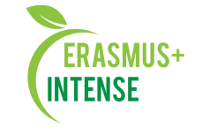

Integrated Doctoral Program for Environmental Policy, Management and Technology – INTENSE

586471-EPP- 1-2017- 1-EE- EPPKA2-CBHE- JP

research capacity issues in khovd state university mongolia
Seminar on Nature

khovd, mongolia, 21 -24 september, 2019

Coordinators:
prof. Bayarkhuu B., Khovd University
assoc. prof. Unurnasan D., Khovd University
INTENSE Partners: EMU, NUM, KhU, ERDAI, MULS
Seminar objectives:
- To discuss and current research result on natural sciences
- To discuss training and curricula of natural sciences

Program schedule - Day 1

Information

Date: [21 September, 2019, Saturday]
Time: [10⁰⁰ – 16⁰⁰]

Location: [Room number 201, ​ Main Building, Erkh Chuluu street-1, Khovd state University of Mongolia]

Attendees: [Bavuu Nyamdorj, Prof. PhD., Rector, ​NUM]

[Ochir Altansukh , PhD., Head, Department of Environment and Forest,

SEAS, ​NUM]

[Anton Shkaruba, PhD., Estonian University of Life Sciences]
[Viktar Kireyeu, ERDA RTE]

[Bayarkhuu B, PhD., Head of Geography and Geology Department, KHU]
[Dagva Unurnasan PhD., Department ofIT and Math, KHU]
[Gulgoo Amarzaya PhD., Department os Foreign Language, KHU]

Time schedule

10⁰⁰-11⁰⁰ | “Graduate programs at the Khovd state university of Mongolia”  Bavuu Nyamdorj, Prof. PhD., Rector, ​KHU
11⁰⁰-12⁰⁰ | "Introduction of Integrated doctoral program for environmental policy, management and technology – INTENSE project"  Anton Shkaruba, PhD., Estonian University of Life Sciences
12⁰⁰-13⁰⁰ | Visit to Distance learning center of Khu
13⁰⁰-14⁰⁰ | Lunch
14⁰⁰-16⁰⁰ | Visit to semi Dessert monitoring station /The Weather station/ of KHU
16⁰⁰-18³⁰ | City tour
19⁰⁰

Program schedule - Day 2

Information

Date: [22 September, 2019, Sunday]

Location: [Room number 413, ​ Main building ,

Erkh Chuluu street-1, Khovd state University of Mongolia]

Time: [10⁰⁰ – 13⁰⁰]

Attendees: [Ochir Altansukh , PhD., Head, Department of Environment and Forest,

SEAS, ​NUM]

[Anton Shkaruba, PhD., Estonian University of Life Sciences]
[Viktar Kireyeu, ERDA RTE]

[Tugjjav Ouynchimeg Professor School of Agro ecology Mongolian university

of life sciences MULS

[Bayarkhuu B, PhD., Head of Geography and Geology Department, KHU]
[Dagva Unurnasan PhD., Department ofIT and Math, KHU]
[Gulgoo Amarzaya PhD., Department os Foreign Language, KHU]
[Tegshjargal N, PhD., Department of Biology and chemistry, KHU]
[Zambuu Burmaa PhD., Department of Biology and chemistry, KHU]
[Battsetseg B, PhD., Department of Geography and Geology, KHU]
[Darikhand D, PhD., Department of Biology and chemistry, KHU]

[Graduate students of KHU]

[Staffs, School of Natural sciences and technology KHU ]

Time schedule

10⁰⁰-13⁰⁰ | Discussions on implementation of INTENSE in Mongolia  [Ochir Altansukh , PhD., Head, Department of Environment and Forest,  SEAS, ​NUM]  Anton Shkaruba, Estonian University of Life Sciences  [Bayarkhuu B, PhD., Head of Geography and Geology Department, KHU]
13⁰⁰-14⁰⁰ | Lunch
14⁰⁰-14⁴⁰ | "Botanical geography research in Altai Mountains"  Davaajav Darikhand, PhD Department of Biology and chemistry KHU
14⁴⁰-15²⁰ | “Herbarium of the Khovd state University”  Demberel Enkhtuul PhD student, Department of Biology and chemistry KHU
15²⁰-16⁰⁰ | Coffee break
16⁰⁰-16⁴⁰ | Perspectives on landscape transformations in rural- urban continuum. Doctor Viktar Kireyeu., Research technology of Education ERDAInstitute, Netherlands
16⁴⁰-17²⁰ | Individual consultations by presenters NUM, MULS, KHU
17⁴⁰-18⁰⁰ | Discussions and Q&A

Program schedule - Day 3

Information

Date: [23 September, 2019, Sunday]

Location: [Room number 413, ​ Main building ,

Erkh Chuluu street-1, Khovd state University of Mongolia]

Time: [10⁰⁰ – 13⁰⁰]

Attendees: [Ochir Altansukh , PhD., Head, Department of Environment and Forest,

SEAS, ​NUM]

[Anton Shkaruba, PhD., Estonian University of Life Sciences]
[Viktar Kireyeu, ERDA RTE]

[Tugjjav Ouynchimeg Professor School of Agroecology Mongolian university of

life sciences

Engineering and Applied Sciences, ​NUM]
[Bayarkhuu B, PhD., Head of Geography and Geology Department, KHU]
[Dagva Unurnasan PhD., Department of IT and Math, KHU]
[Gulgoo Amarzaya PhD., Department os Foreign Language, KHU]
[Tegshjargal N, PhD., Department of Biology and chemistry, KHU]
[Zambuu Burmaa PhD., Department of Biology and chemistry, KHU]
[Battsetseg B, PhD., Department of Geography and Geology, KHU]
[Darikhand D, PhD., Department of Biology and chemistry, KHU]

[Graduate students of KHU]

[Professors, School of Natural sciences and technology KHU ]

Time schedule

10⁰⁰-11⁰⁰  11⁰⁰-12⁰⁰  12⁰⁰-12³⁰  12³⁰-13⁰⁰  13⁰⁰-14⁰⁰  14⁰⁰-15⁰⁰  15³⁰-16⁰⁰  16⁰⁰-16³⁰  16³⁰-17³⁰ | Accurate estimation of river catchment boundary using DEM , prof. Altansukh O., National University of Mongolia (NUM)  " Current studies of lake and river ecosystems in Great lakes depression."  [Zambuu Burmaa PhD., Department of Biology and chemistry, KHU]  Coffee break  " Environmental impact assessment and auditing (process) issues in Mongolian education system "  [Tugjjav Ouynchimeg Professor School of Agroecology Mongolian university of life sciences MULS  Lunch  Resaech on Ecology of Soil in the river basin Buyant gol, Western Mongolia"  [Battsetseg B, PhD Candidate NUM., Department of Geography and Geology, KHU]  " Some on the Lexis of toponyms Antimistic belief in place-names "  [Gulgoo Amarzaya PhD., Department os Foreign Language, KHU]  Solar energy research of Western, optimal use of resources. Ms.S Zolbayar J., Khovd University  Visit to Mayor office of th city Khovd

Program schedule - Day 4

Information

Date: [24 September, 2019, Sunday]

Location: [Field trip To Hign Mountain Tsambagarav Mongolian Altai, Western Mongolia

Time: [10⁰⁰ – 19⁰⁰]

Attendees: [Ochir Altansukh , PhD., Head, Department of Environment and Forest,

SEAS, ​NUM]

[Anton Shkaruba, PhD., Estonian University of Life Sciences]
[Viktar Kireye, Prof., PhD., University of Latvia]

[Tugjjav Ouynchimeg Professor School of Agroecology Mongolian university of

life sciences

Engineering and Applied Sciences, ​NUM]
[Bayarkhuu B, PhD., Head of Geography and Geology Department, KHU]
[Dagva Unurnasan PhD., Department of IT and Math, KHU]
[Gulgoo Amarzaya PhD., Department os Foreign Language, KHU]
[Tegshjargal N, PhD., Department of Biology and chemistry, KHU]
[Zambuu Burmaa PhD., Department of Biology and chemistry, KHU]
[Battsetseg B, PhD., Department of Geography and Geology, KHU]
[Darikhand D, PhD., Department of Biology and chemistry, KHU]

[Graduate students of KHU]

[Professors, School of Natural sciences and technology KHU ]

Time schedule

10⁰⁰-13⁰⁰  12⁰⁰-13⁰⁰  13⁰⁰-19⁰⁰  19⁰⁰-20³⁰ | Study trip in the area of semi dessert zone, Westren Mongolia"  40 km from City Khovd, Mongolia  Moderator [Bayarkhuu B, PhD., Head of Geography and Geology Department, KHU]  Lunch  Study trip to high mountain Tsambagarav, Mongolian Altai, Western Mongolia  Back to the city

Saturday, 21th September, 2019 - Visit to semi Dessert monitoring station /The Weather station/ of KHU 10 min Driving

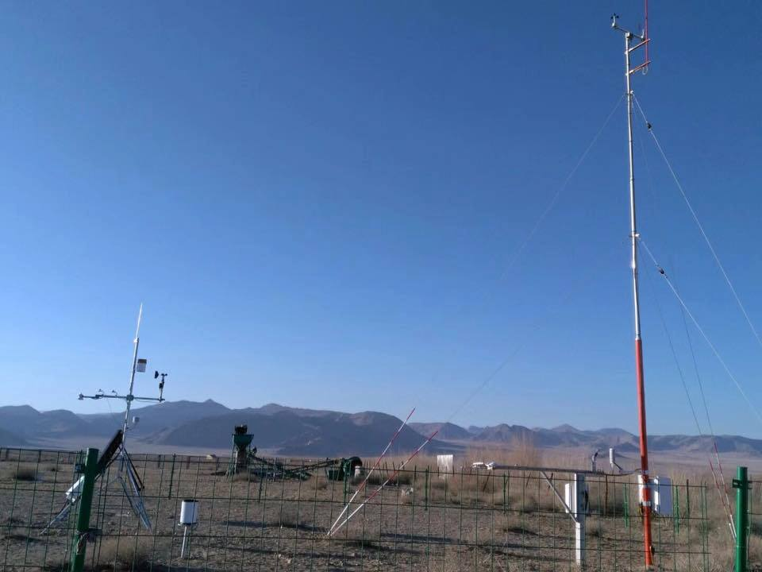

Tuesday, 24th September, 2019 - Visit to semi Dessert area /40 km/ and Hign mountain Tsambargav Mongoilian Altai, Western Mongolia 180 km

List of participants

1 | Anton | Shkaruba | Estonian University of Life Sciences | EE
2 | Viktar | Kireyeu | Research technology of Education ERDAInstitute, Netherlands | NLD
3 | Altansukh | Ochir | National University of Mongolia NUM | MN
4 | Oyunchimeg | Tugjjav | Mongolian University of Life Sciences MULS | MN
5 | Bayarkhuu | Batbayar | Khovd University | MN
6 | Amarzaya | Gulguu | Khovd University | MN
7 | Amarjargal | Ayurzana | Khovd University | MN
8 | Unurnasan | Dagva | Khovd University | MN
9 | Burmaa | Zambuu | Khovd University | MN
10 | Tserengombo | Tseveen | Khovd University | MN
11 | Oyuntsetseg | Chultem | Khovd University | MN
12 | Tegshjargal | Nanzaddorj | Khovd University | MN
13 | Dorj | Setev | Khovd University | MN
14 | Enkhtuul | Demberel | Khovd University | MN
15 | Battsetseg | Duger | Khovd University | MN
16 | Zolbayar | Jargalsaikhan | Khovd University | MN
17 | Dorj | Setev | Khovd University | MN
18 | Lkhagvasuren | Choijinjav | Khovd University | MN
19 | Otgonbayar | Demberel | Khovd University | MN
20 | Ganchimeg | Dorj | Khovd University | MN
21 | Gantumur | Baasandorj | Khovd University | MN
22 | Ayurzana | Chantuu | Khovd University | MN
23 | Amarjargal | Erdene | Khovd University | MN
24 | Narankhuu | Erdenejargal | Khovd University | MN

