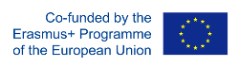
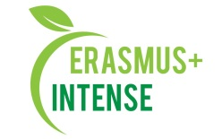

REPORT
on the workshop
for dissemination of results of individual scientific internship

Date: 09 September 2021
Time: 15.00
Number of participants: 17 (registration list is attached)
Speakers: S. Burchenko, V. Voronin

The aim of the workshop was presentation of the information of individual scientific internship that was in Lviv, Ukraine .
Target audience: Master and PhD students, academic staff.

PhD student S. Burchenko, V. Voronin took part in an individual scientific internship in the Institute of Ecology of the Carpathians of the National Academy of Sciences of Ukraine (Lviv, Ukraine) and on the workshop they made a presentation of the internship, their experience and opinion about the event. The aim was to promote INTENSE project, to share new knowledge and emotions.
After presentation participants asked questions about faculty of the internship, field trips, how they will introduce new knowledge into their research etc.

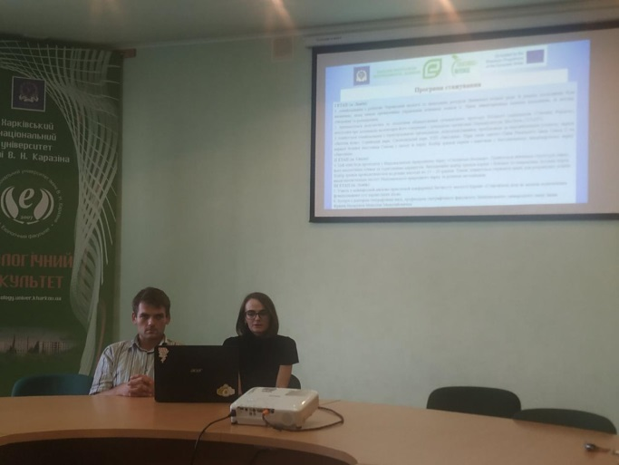 | 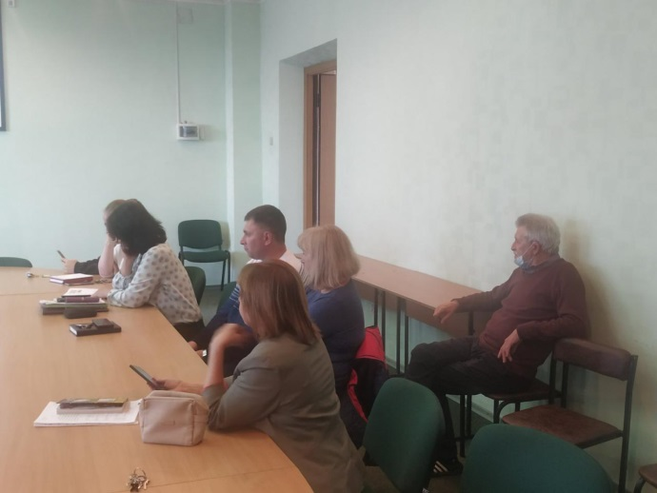
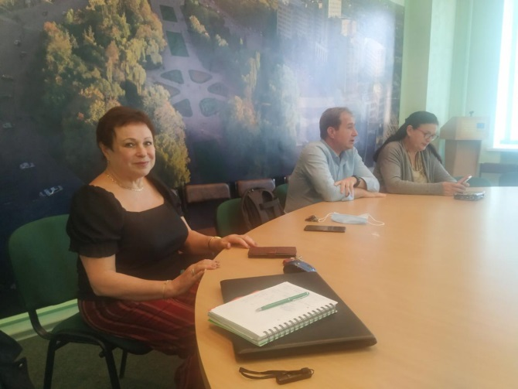 | 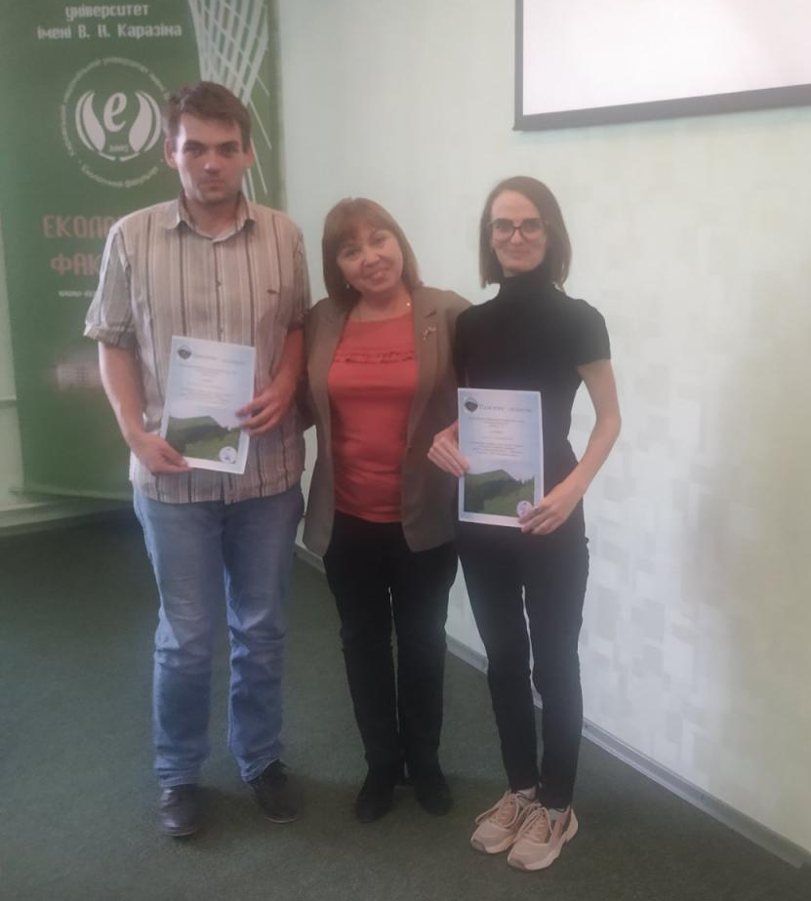

Conclusions:
- An individual scientific internship was very valuable for participants and well-organised;
- Field trip was very interesting and useful as a practical part and meeting with stakeholders;
- S.Burchenko, V.Voronin will introduce new knowledge into their research;
- They have established new contacts those will be useful in their future carrier.

Information:
https://ecology.karazin.ua/mizhnarodna-dijalnist/intense-integrated-doctora/treningi/
https://ecology.karazin.ua/news/naukovij-seminar-za-rezultatami-individualnogo-stazhuvannja-aspirantiv/

