V.N. Karazin Kharkiv National University
ERASMUS+ project “Integrated Doctoral Program for Environmental Policy, Management and Technology – INTENSE”

REPORT
of individual scientific internship
PhD students: Voronin Vladislav and Burchenko Svitlana
Period: 14 – 27 June 2021

2021

Green and blue infrastructure is the framework for sustainable urban development and their adaptation to climate change. Each city has its own geographical features and specifics of management of green areas and water bodies. Stakeholder participation in city landscaping projects is one of the most important aspects.
14 – 27 June 2021 took an individual scientific internship at the Institute of Ecology of the Carpathians of the National Academy of Sciences of Ukraine. The purpose of the internship was to conduct individual research on topics of dissertations.
Was held an online competition and based on the results Svitlana Burchenko and Vladislav Voronin – PhD students of the Department of Environmental Monitoring and Protected Area, were selected to participate.
The task of the internship was to conduct research on dissertations – the study of green infrastructure in Lviv for comparison of approaches to the development and management of green infrastructure in Kharkiv (S. Burchenko); identification of ecosystem services of urban and natural forest landscapes, by selection and further analysis of tree core samples (V. Voronin).
The internship consisted of three stages:
- 14 – 18 June: the first stage was in Lviv;
- 18 – 21 June: the second stage was in National Nature Park “Skolivski Beskydy”;
- 21 – 24 June: the third stage was in Lviv;
- 24 – 27 June: generalization and processing of the obtained results.

The following tasks were planned and completed:
1. visit to the Department of Ecology and Natural Resources of the Lviv City Council. Within the framework of the research, it was determined how is organized the management of the green infrastructure of Lviv, the inventory of green spaces, caring of them, the creation of new green spaces and the expansion of existing green zones;

2. participation in the initiative of arranging public space of urban gardening “Greenhouses of Rering” together with NGO “Plato”, “EkoTerra”, “Permaculture”;
3. study the management of green areas of Lviv, territorial organization, subordination, problems and perspectives for the development of parks – “Zalizna Voda”, “Stryiskyi Park”, Regional Landscape Park “Znesinnya ”, “Park of Holy Pope Ivana Pavla II” and the first Green Eco trail of Sykhiv, “Snopkivskyi park”;
4. study of the structure of the National Nature Park “Skolivski Beskydy”, its ecological trails and tourist routes, ecosystem services provided by the park;
5. participation in the international scientific-practical conference of the Institute of Ecology of the Carpathians “Old-growth forests as a model of Carpathian forests’ restoration”;
6. meeting with Nazaruk Mykola – Doctor of Geography, Professor of the Department of Geography in Ivan Franko National University of Lviv.

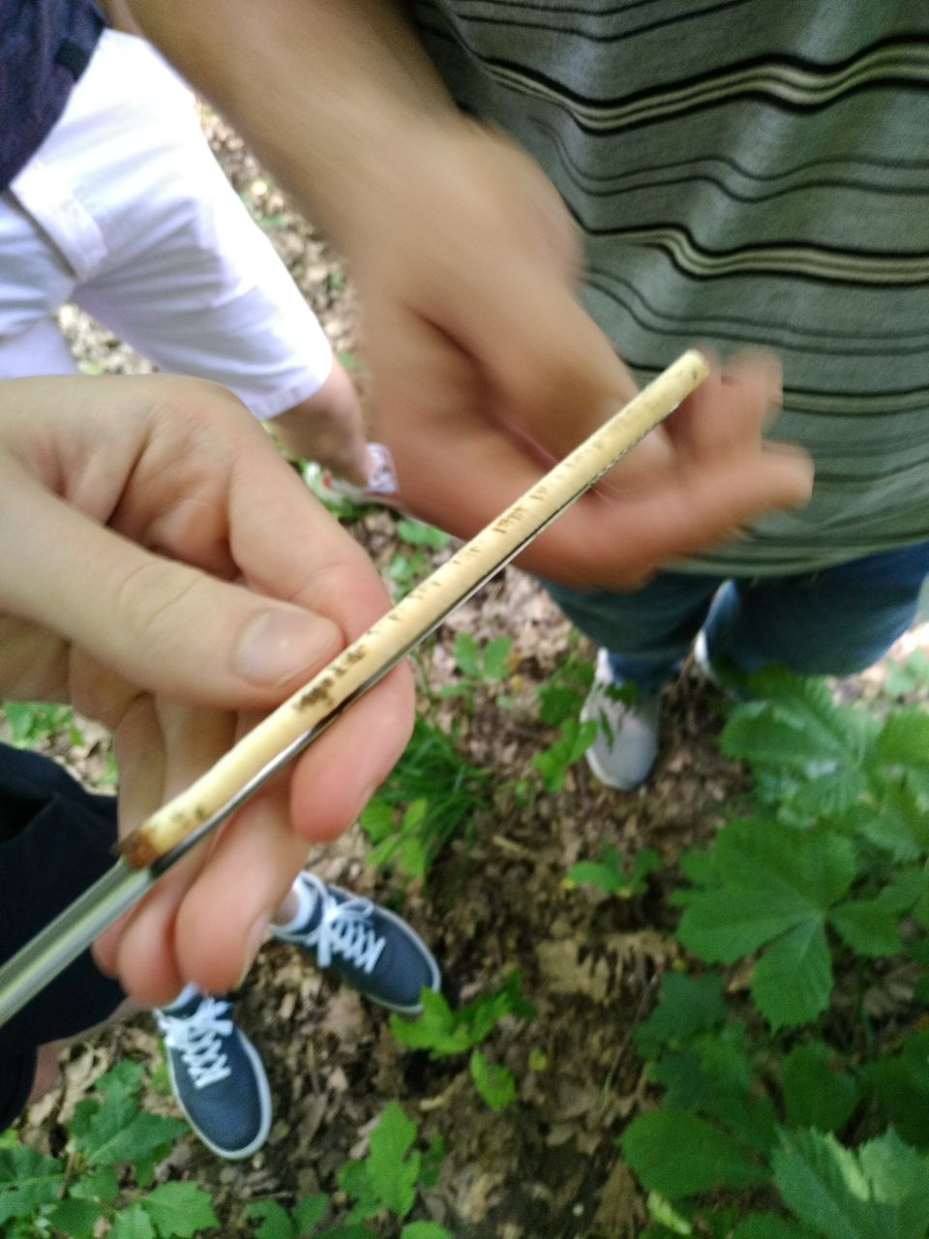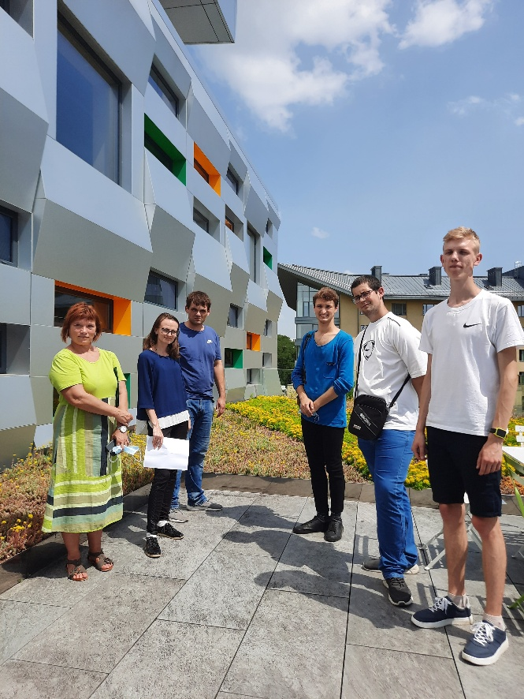

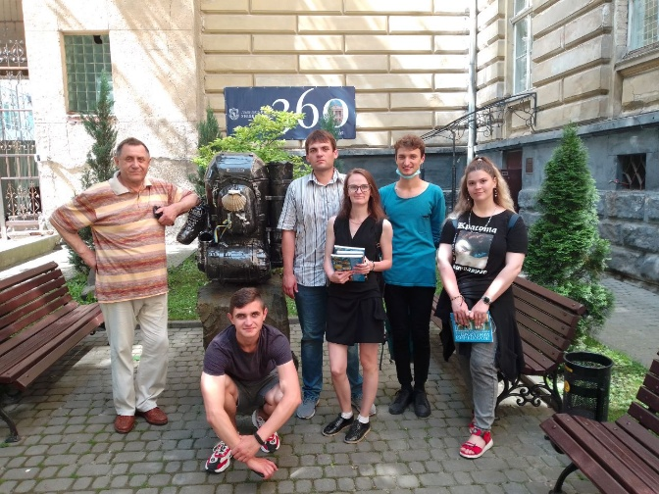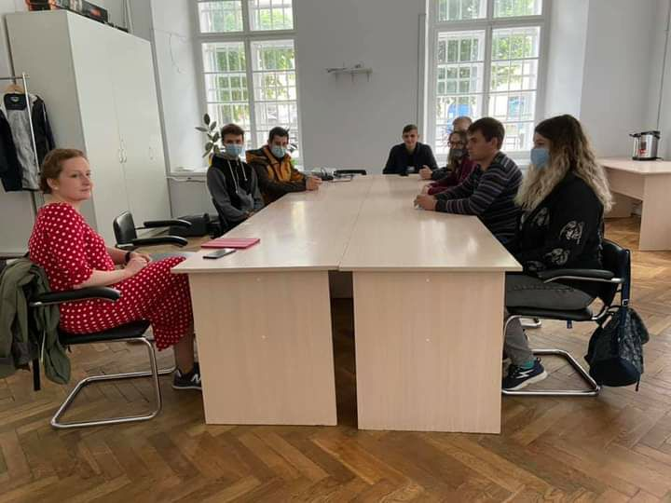
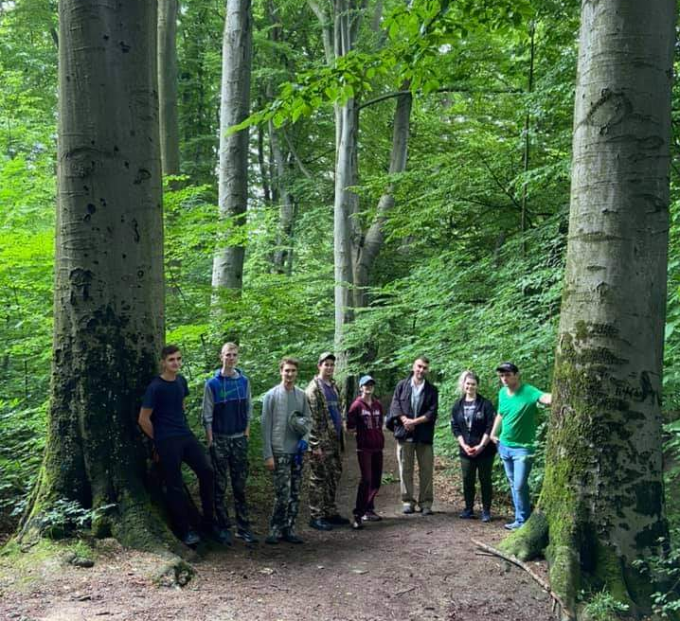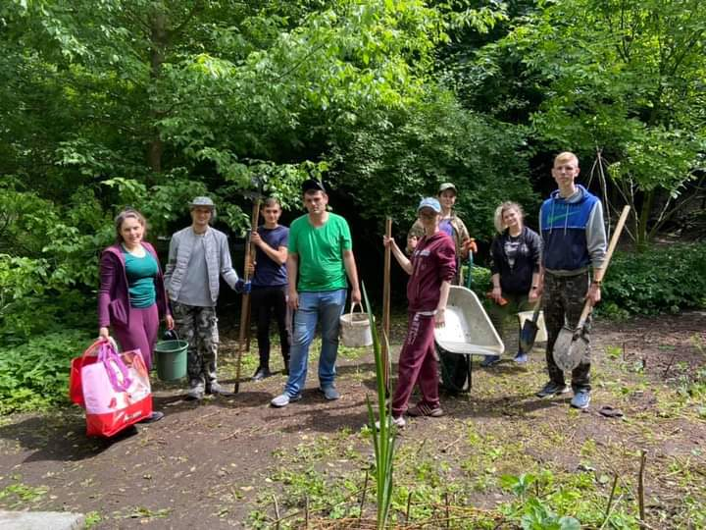

Detailed information posted: https://ecology.karazin.ua/mizhnarodna-dijalnist/intense-integrated-doctora/treningi/

The results were presented at a scientific seminar that was on September 9, 2021, target audience – students, PhD students, professors. The total number of participants – 18. PhD students made a presentation and answered the questions.

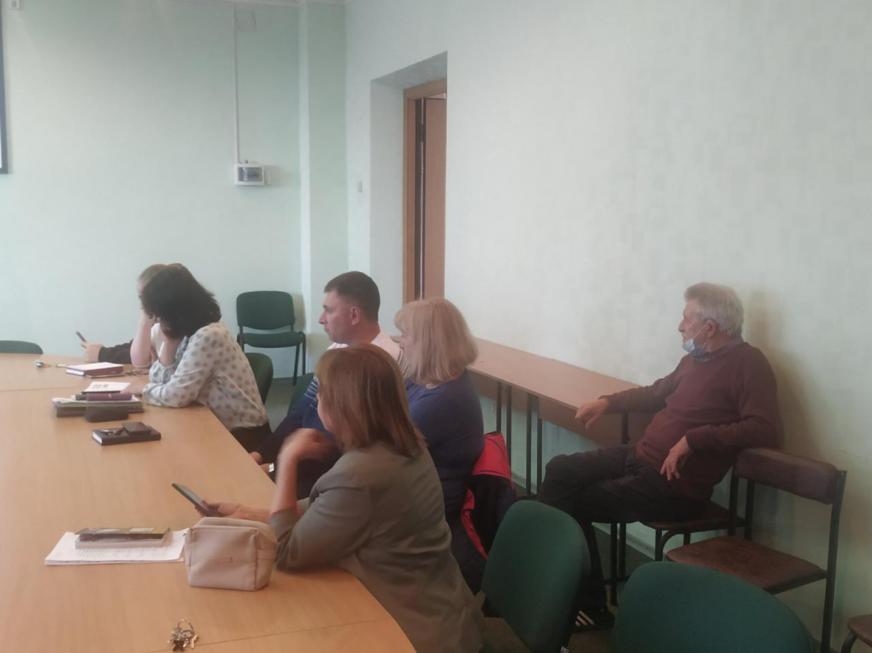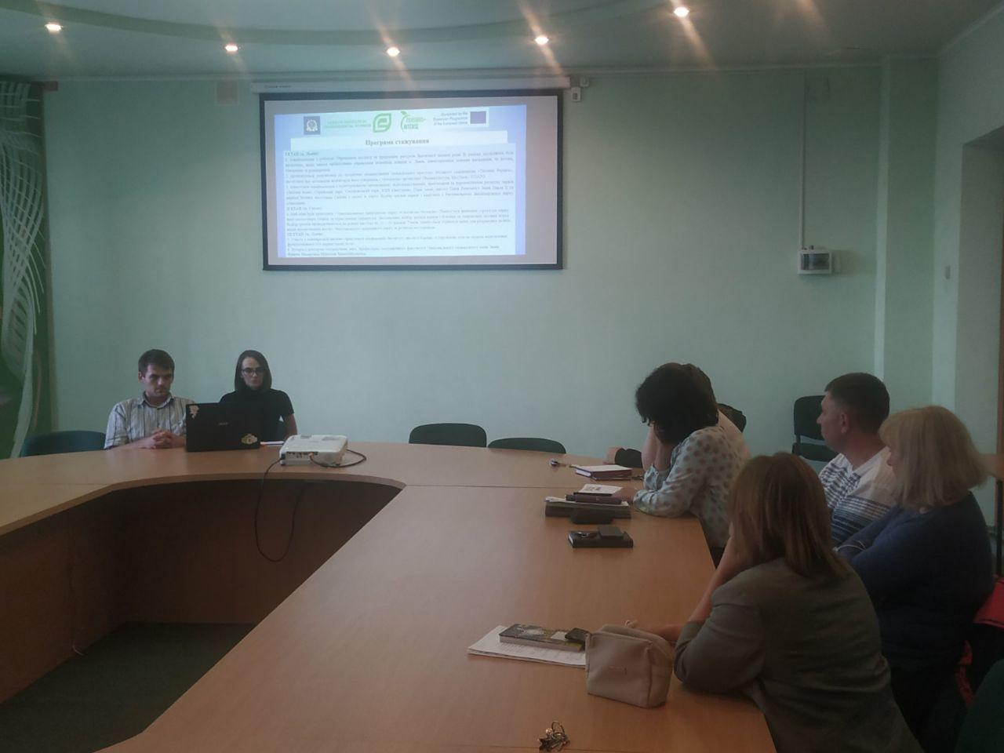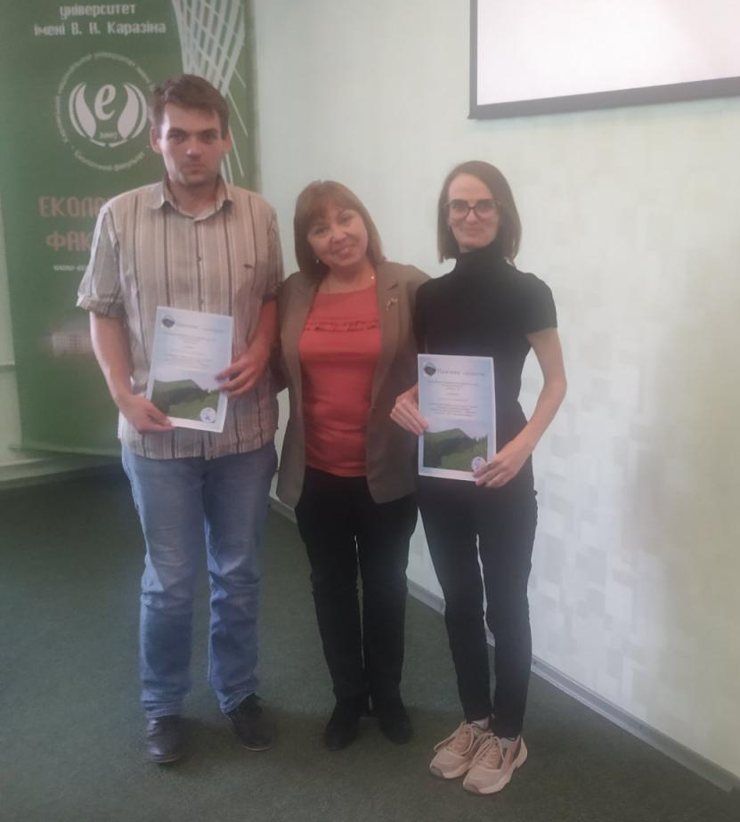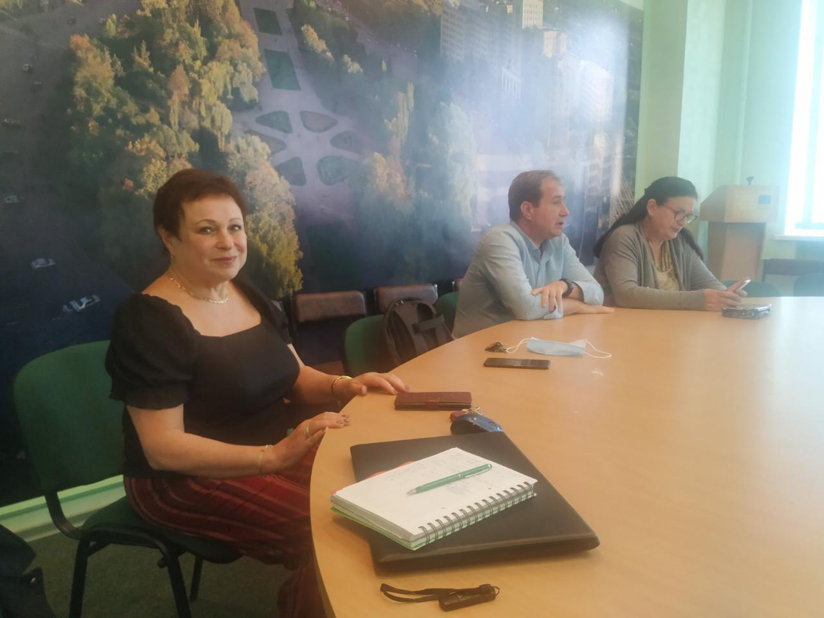

Detailed information posted: https://ecology.karazin.ua/mizhnarodna-dijalnist/intense-integrated-doctora/treningi/

