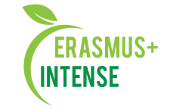
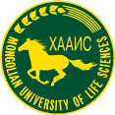

THE REPORT FOR THE

research capacity issues in khovd state university mongolia
Seminar on Nature

khovd, mongolia, 21 -24 september, 2019

Title: | Integrated doctoral program for environmental policy, management and technology - INTENSE
Number: | 586471-EPP-1-2017-1-EE-EPPKA2-CBHE-JP
Coordinator: | Khovd University
Participant: | National University of Mongolia  Insitute for sustainable development, NUM  Mongolian university of Life sceinces MULS  ERDA institute  Estonian university of Life sceinces EMU

Background information:
The INTENSE national agreement between Mongolian partners has been signed on 26th April 2019. The objective of the agreement is to establish and to strengthen the INTENSE national program for graduate study. As agreed Mongolian partners of the INTENSE project, the mid term partner seminar is organized between 21 September and 24 september 2019, in total 4 days. In total, 25+ staffs and Ph.D students the KHU, NUM, MULS been participated. Agenda is attached. Appendix 1

Coordinators:
prof. Bayarkhuu B., Khovd University
assoc. prof. Unurnasan D., Khovd University
INTENSE Partners: EMU, NUM, KhU, ERDAI,
Seminar objectives:
- To discuss and current research result on natural sciences
- To discuss training and curricula of natural sciences
- To organize individual concultation presenters and establish future collaboration

The first day (21 September 2019) of the visit:
According to the agenda, the team members arrived UB city. (Anton Shkaruba EMU, Viktar Kireye, ERDA Institute, Ochir Altansukh NUM )
Rector of the Khovd University, Professor B.Nyamdorj introduced the “Graduate programs at the Khovd state university of Mongolia”, and Introduced by Anton Shkaruba the project “ Integrated doctoral program for environmental policy, management and technology – INTENSE project".
Seminar participants visited to Distance laerning center of Khovd University and Semi Dessert monitoring station /The Weather station/ and University museum of KHU.

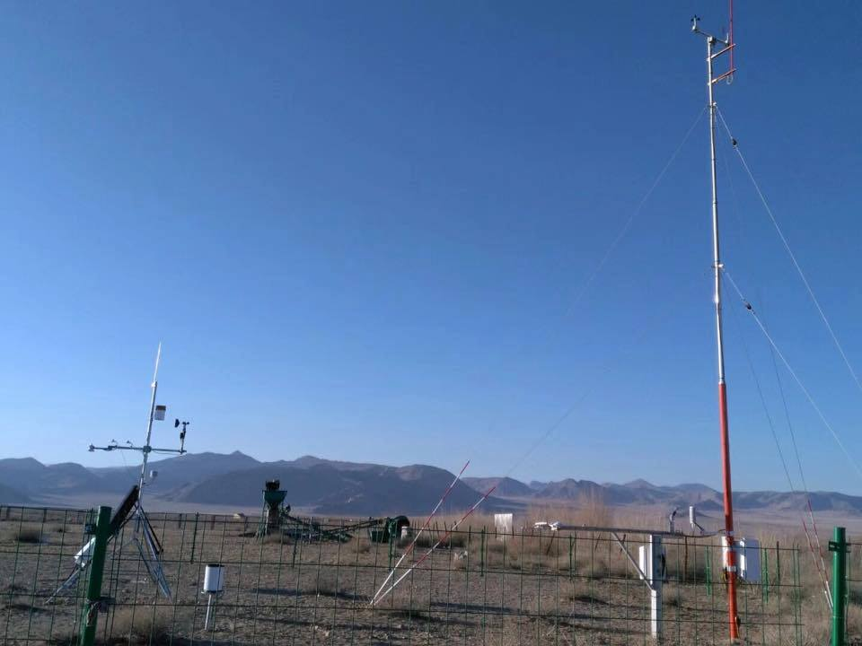
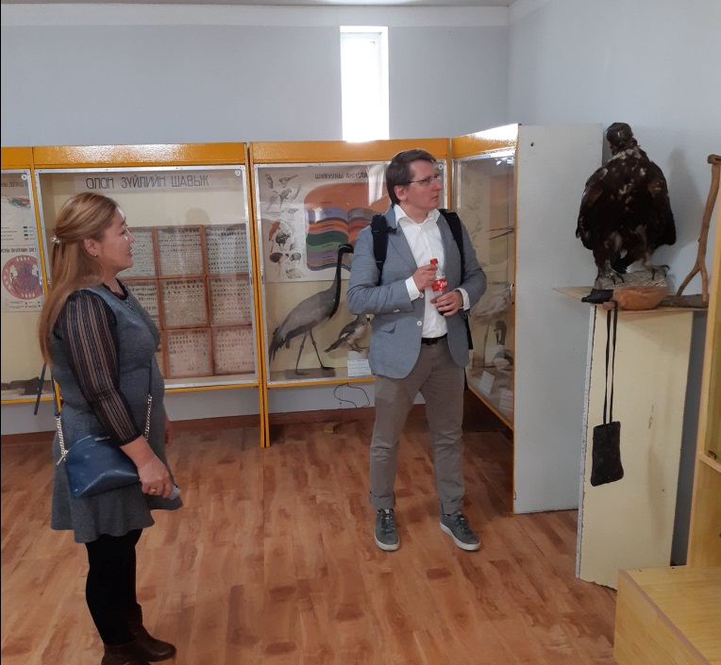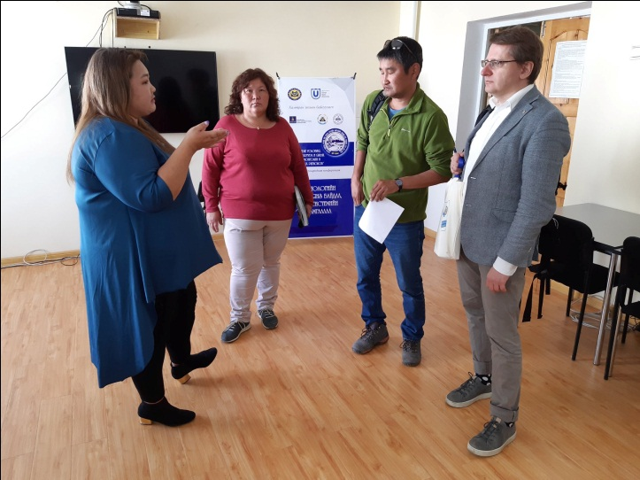

Welcome dinner hosted by representatives of KHU administration

The second day (22September 2019) of the visit:
Contuned the seminar ‘‘Research on Nature‘‘

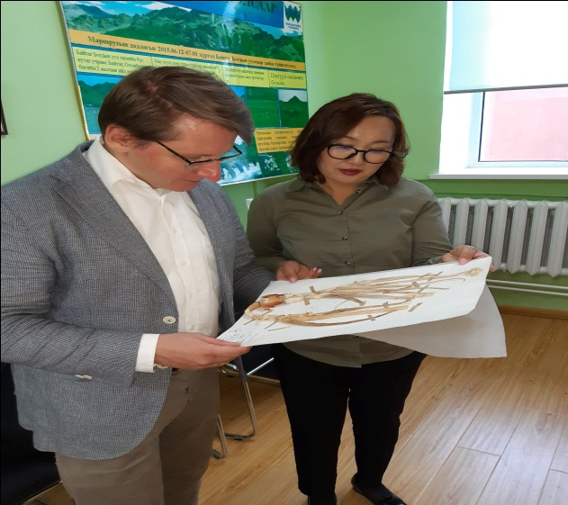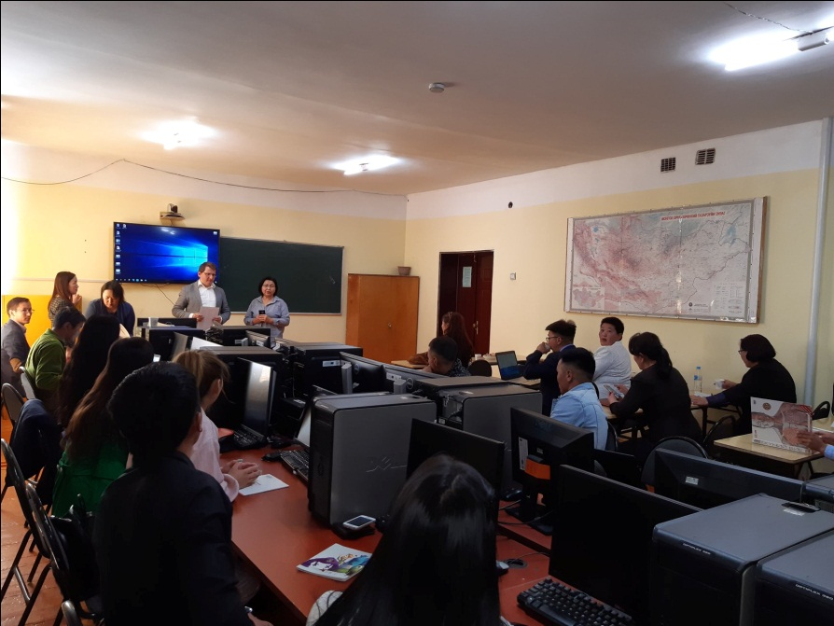
The third day (23September 2019) of the visit:
Contuned the seminar ‘‘Research on Nature‘‘
Visited to the Maoyr office if Khovd city, Mongolia

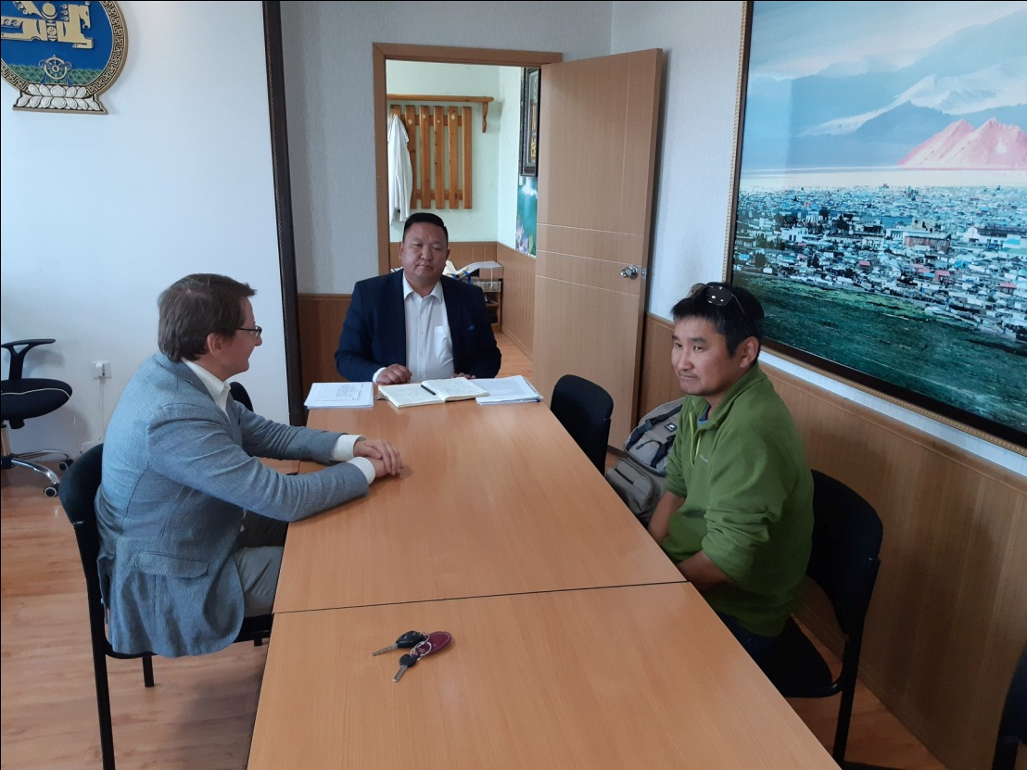

The fourth day (24September 2019) of the visit
- Study trip in the area of semi dessert zone, Westren Mongolia"
40 km from City Khovd, Mongolia
- Study trip to high mountain Tsambagarav, Mongolian Altai, Western Mongolia 180 km

