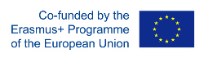
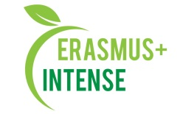

REPORT
on the XXII International Conference
“Ecology, environmental protection and balanced environmental management: education – science – production – 2019”

Date: 17 - 18 April 2019
Agenda is attached
Number of abstracts: 50 (proceedings are attached)
On-line registration, number of participants: 51 (registration list is attached)

The aim of the conference is sharing experience and scientific knowledge as well as discussion of urgent issues on environmental protection.
Target audience: Master, PhD students, academic staff, research staff, professionals working in industries, consulting and NGOs.
There were following themes:
- Innovation approaches for solutions of environmental problems:
  - Air pollution;
  - Water pollution;
  - Soil depletion;
  - Waste management.
- Environmental education: best practices:
  - Secondary school;
  - Higher education;
  - Life-Long Learning.

International cooperation for environmental protection:

Scientific and educational programmes and projects;

International Visegrad Foundation “Political and economic aspects of biodiversity conservation in V4 countries”;

Erasmus+ programme, Jean Monnet Module “Instruments of the EU Environmental Policy – INENCY”;

Erasmus+ programme “Integrated Doctoral Program for Environmental Policy, Management and Technology – INTENSE”.
Also a workshop on INTENSE and INENCY projects was organized.
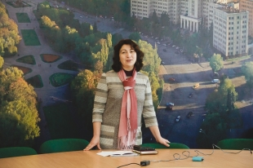 | 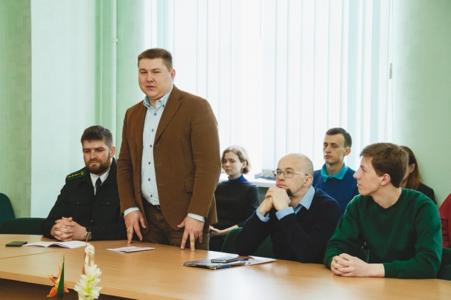
 | 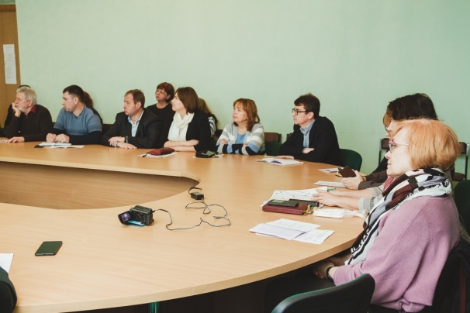

Conclusions:
- Sharing of knowledge and discussions are very crucial in professional life of academic and scientific staff as well in life of professionals working in industries, consulting and NGOs;
- International cooperation will assure introduction of best practices in education process.
Information:
https://www.univer.kharkov.ua/ua/research/all_conferences/conferences?news_id=8825
http://ecology.karazin.ua/vorkshop-za-proektami-erasmus/

