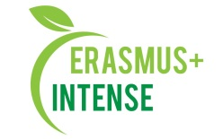

REPORT
on the Conference
“XV All-Ukrainian scientific Talliiv’s reading’s”

Date: 30 October, 2019
Agenda is attached
Number of abstracts: 49 (proceedings are attached)
Number of participants: 89, including attended 23 (registration list is attached)

The aim of the conference is sharing experience and scientific knowledge of problems of the protected areas well as discussion of urgent issues on environmental protection.
Target groups are scientists, teachers, students who study conservation areas and participate in international cooperation for environmental protection in the Project of International Visegrad Foundation, INTENSE project and INENCY project partners as well as wide scientific community.
There were following themes:
1. Modern problems of rational nature management and nature protection.
2. Assessment of the ecological condition of components and complexes of the environment.
3. Scientific and educational problems of protected areas in Ukraine. International cooperation for environmental protection.

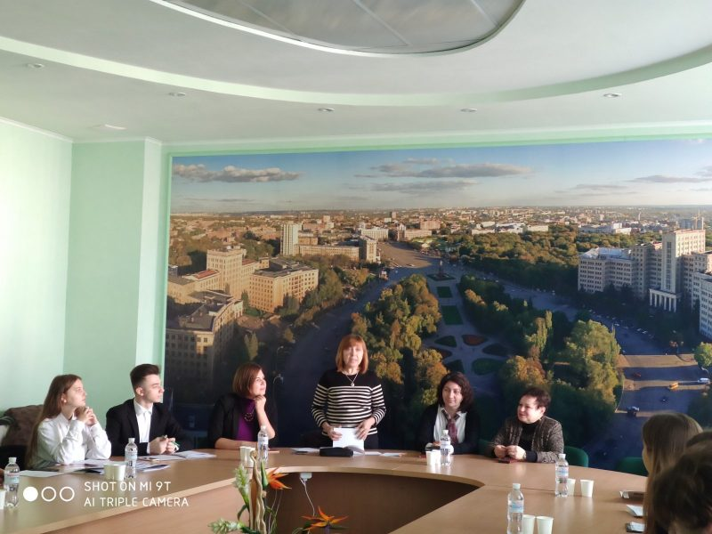 | 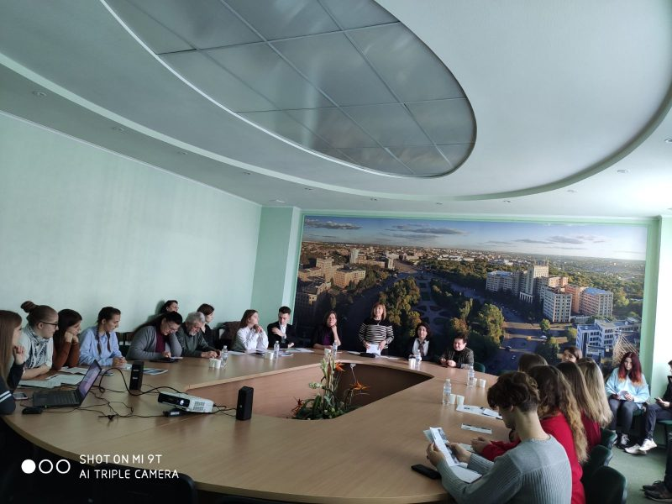
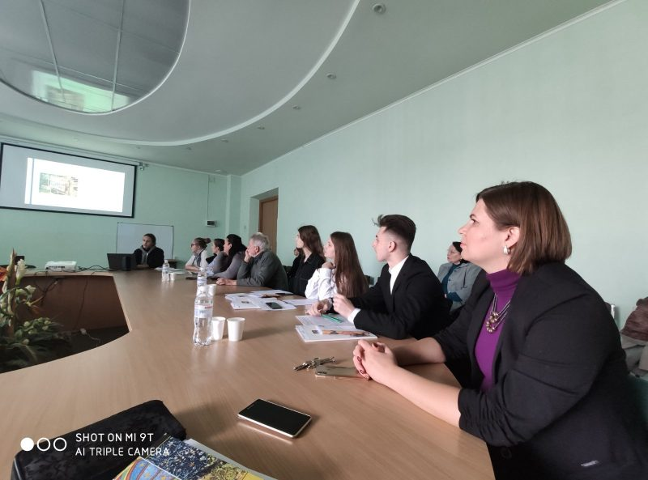 | 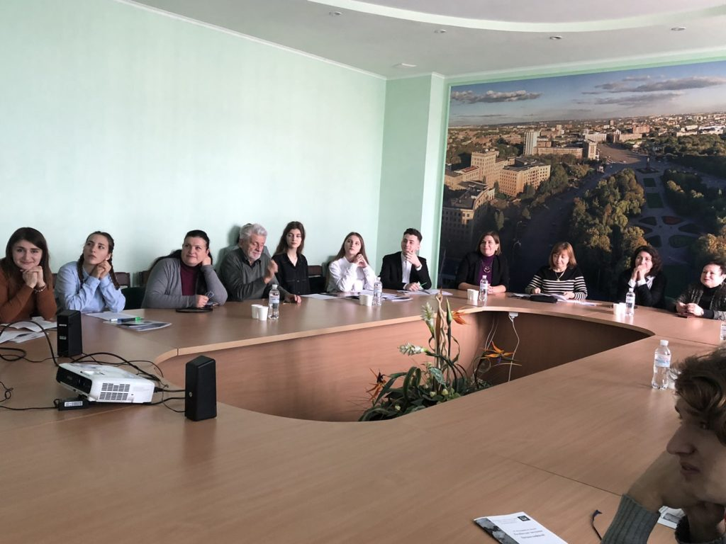

Conclusions:
- All-Ukrainian scientific was very valuable for participants;
- Sharing of knowledge about modern problems of rational nature management and nature protection are very crucial in professional life of academic and scientific staff;
- Scientific and educational problems of protected areas in Ukraine are very crucial for science and education;
- International cooperation for environmental protection will assure the introduction of best practices in the education process.
Information:
http://ecology.karazin.ua/vidbulisja-xv-vseukrainski-naukovi-taliivski-chitannja/
http://ecomonitoring.karazin.ua/?p=2347
Abstracts: http://ecology.karazin.ua/wp-content/uploads/2019/11/taliev-2019.pdf

