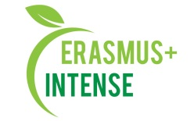

REPORT
on the Science-policy seminar “INSTRUMENTS OF EU ENVIRONMENTAL POLICY FOR UKRAINE”

Date: 19 February 2019
Time: 10.00 – 18.00
Number of participants: 25 (registration list is attached)
Speakers: S. V. Burchenko, A. Klieshch
The aim of the workshop was exchange of experience, discussion of ways to form environmental policy, as well as requirements for the training of specialists in the field of ecology at the bachelor's, master's and PhD levels.
Target audience: Master and PhD students, academic staff, practitioners in the field of environmental policy.
19 February 2019 оn the science-policy seminar PhD students S. V. Burchenko аnd A. Klieshch made presentations about results of their scientific activity. The participants presented the following topics:
- А. Klieshch "Reconstruction of urban history and natural landscapes for landscape - ecological planning on the example of Kharkiv".
- S. V. Burchenko "Structural and geographical foundations of the concept of "green infrastructure" for the Kharkiv region".
The reports were devoted to the possibilities and importance of the formation of an integrated environmental policy by local and regional authorities to solve the problems of urban development planning and green infrastructure management.
The presentations sparked a lively discussion among other participants, especially invited practitioners. The key issues in the discussion were:
- features of modern approaches to the formation of the ecological policy of Ukrainian cities,
- problems and shortcomings the formation of ecological development goals at the regional level in Ukraine.

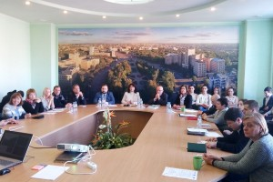 | 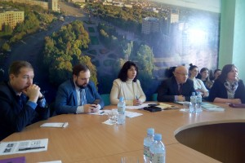
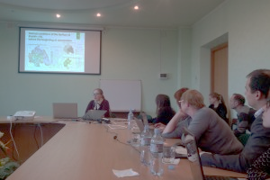 | 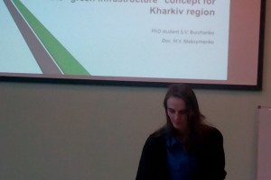

Conclusions:
- the research of the possibilities of introducing European instruments for the formation of environmental policy in the practice of environmental planning and management tasks in Ukraine is very urgent;
- the development of information tools for the formation of environmental policy in Ukraine is the key to its transparency and democracy.
Information:
http://ecology.karazin.ua/mizhnarodna-dijalnist/intense-integrated-doctora/treningi/
https://ecology.karazin.ua/news/zaproshuiemo-na-seminar-za-proiektami-erazmus/
https://ecology.karazin.ua/wp-content/uploads/2020/07/inency_2_agenda_feb19_final.pdf
http://ecomonitoring.karazin.ua/?p=1892&lang=uk

