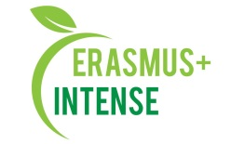

REPORT
on the workshop
Summer school “The Precautionary Principle in Sustainability Transitions: Thinking forwards, Looking backwards, Acting”

Date: 13 September 2018
Time: 15.00
Number of participants: 12 (registration list is attached)
Speakers: O. Volkovaya, O. Chernikova

The aim of the workshop was presentation of the information on the summer school “The Precautionary Principle in Sustainability Transitions: Thinking forwards, Looking backwards, Acting” that was in Budapest, Hungary.
Target audience: Master and PhD students, academic staff.

13 September on the workshop O.Volkovaya and O.Chernikova made a presentation about the summer school, precautionary principle concept, speakers, type of made works. Special attention was given to presenting group works those were on the summer school. In the end they said some words about cultural and social life on the summer school.
After presentation participants asked questions about the content, scientific part, potential of integration of precautionary principle concept into UA reality, benefits they received during study and what emotions and experience were most valuable.

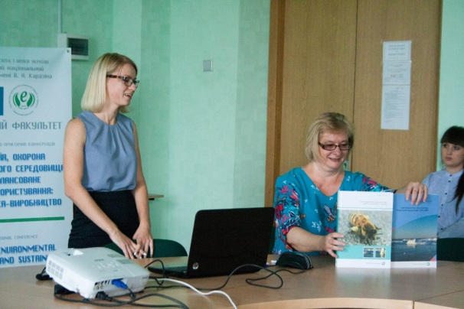 | 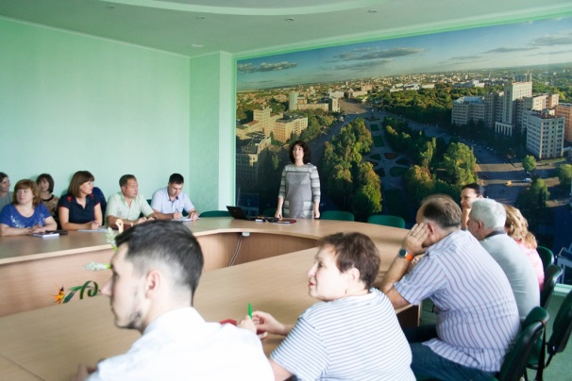
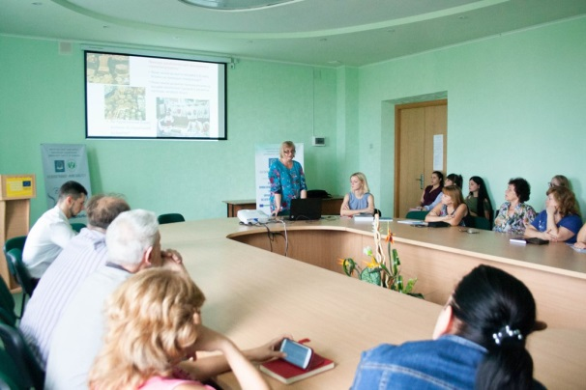 | 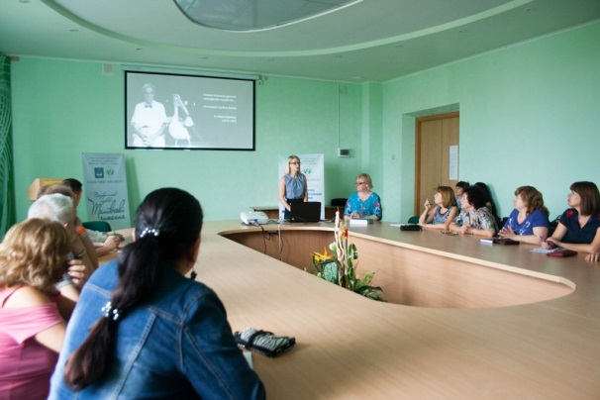

Conclusions:
- Summer school “The Precautionary Principle in Sustainability Transitions: Thinking forwards, Looking backwards, Acting” was very intensive and useful for participants;
- Precautionary principle can be considered as the advanced topic of sustainability;
- Participation in such event gives many benefits, improves social skills and gives possibility to developed network for the participants.

Information:
http://ecology.karazin.ua/mizhnarodna-dijalnist/intense-integrated-doctora/treningi/
http://ecology.karazin.ua/seminar-za-rezultatami-litnoi-shkoli/

