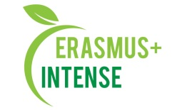

REPORT
on the workshop
Summer school “NATURE-BASED SOLUTIONS FOR SMART CITIES”

Date: 20 September 2018
Time: 15.00
Number of participants: 12 (registration list is attached)
Speakers: S. Shyrokostup, V. Dudchenko

The aim of the workshop was presentation of the information on the summer school “NATURE-BASED SOLUTIONS FOR SMART CITIES” that was in Mahiliov, Belarus.
Target audience: Master and PhD students, academic staff.

20 September 2018 on the workshop S. Shyrokostup, V. Dudchenko made a presentation about the summer school. The presentation included information about the summer school, organisers, organizational issues, speakers, key topics and results. Special attention was given to presenting group works those were on the summer school. In the end they said some words about cultural and social life on the summer school.
After presentation participants asked questions about the following:
- the scientific background,
- smart city: what does it mean,
- comparison of Ukrainian and Belarusian legislation and practices,
- how the results will be introduced into their PhD thesis,
- nature-based solutions: potential for wide use in UA reality.
potential of integration of precautionary principle concept into UA reality, benefits they received during study and what emotions and experience were most valuable.
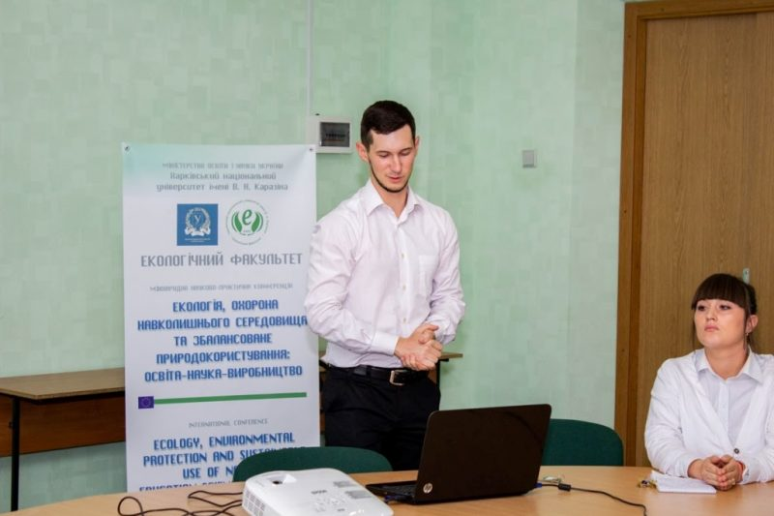
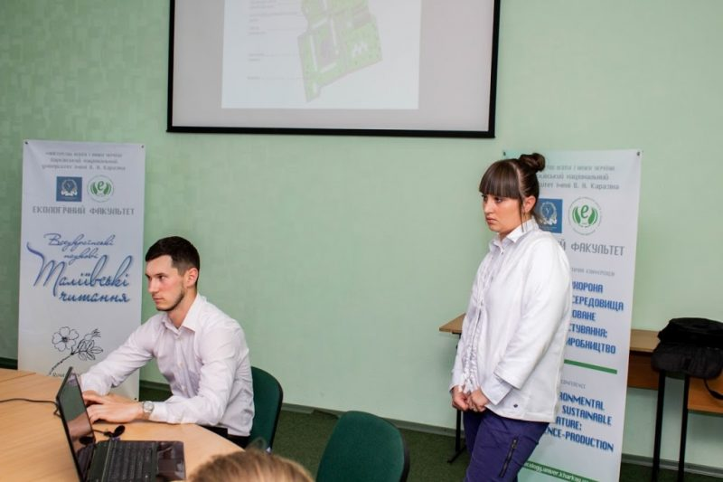 | 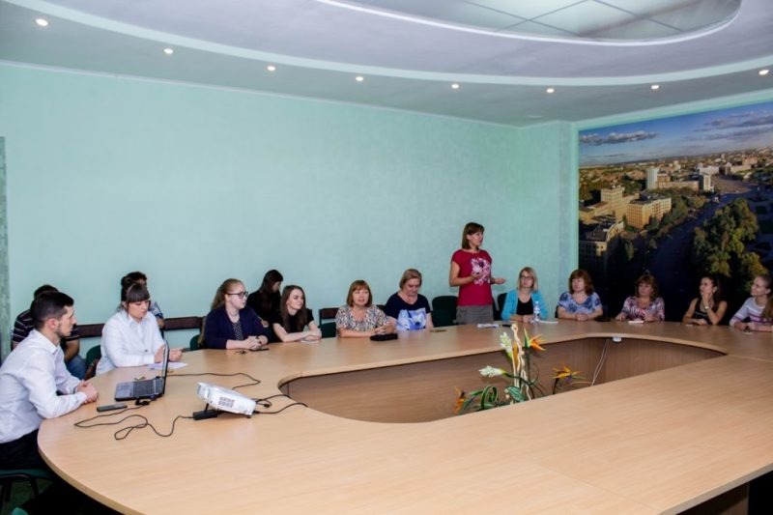

Conclusions:
- Summer school “Nature-Based Solutions for Smart Cities” was very intensive and useful for participants;
- Nature-based solutions can be widely used in UA town and settlements;
- Special recommendation should be given to decision-makers;
- Such event gives many benefits, improves social skills and gives possibility to developed network for the participants.

Information:
http://ecology.karazin.ua/mizhnarodna-dijalnist/intense-integrated-doctora/treningi/
http://ecology.karazin.ua/seminar-za-pidsumkami-litnoi-shkoli/

