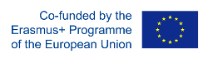
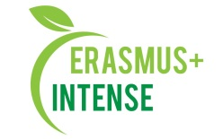

REPORT
on the workshop
Summer school “WIN! Water Innovations Policy, Management, Research”

Date: 01 November 2019
Time: 15.00
Number of participants: 17 (registration list is attached)
Speakers: S. Burchenko

The aim of the workshop was presentation of the information on the summer school “WIN! Water Innovations Policy, Management, Research” that was in Tartu, Estonia.
Target audience: Master and PhD students, academic staff.

PhD student S. Burchenko took part in a summer school “WIN! Water Innovations Policy, Management, Research“ (Tartu, Estonia) and on the workshop she made a presentation of the summer school, her experience and opinion about the event. The aim was to promote INTENSE project, to share new knowledge and emotions.
After presentation participants asked questions about faculty of the summer school, field trips, how she will introduce new knowledge into her research etc.

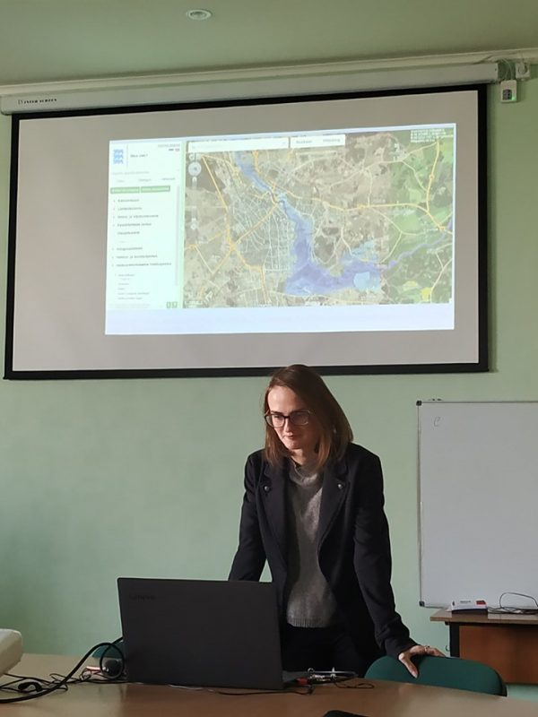 | 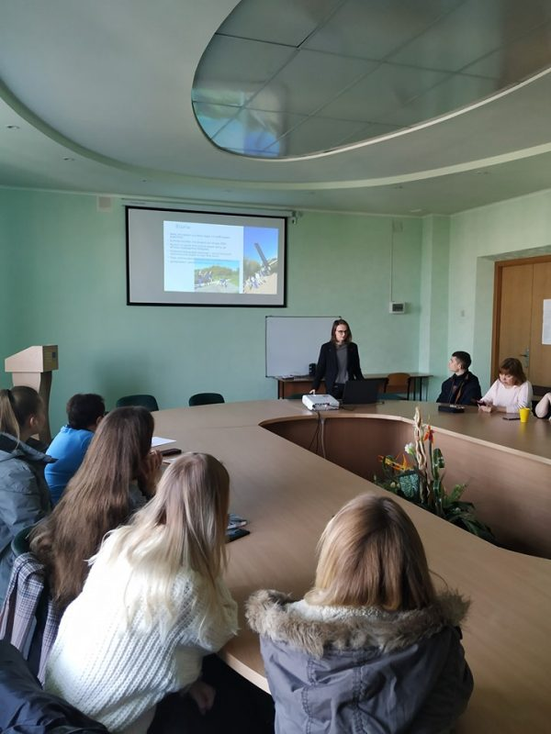
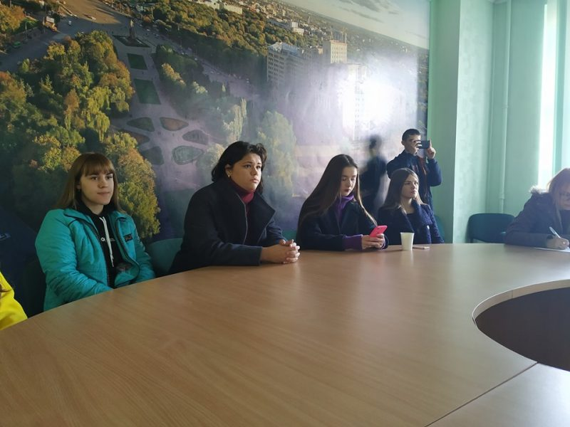 | 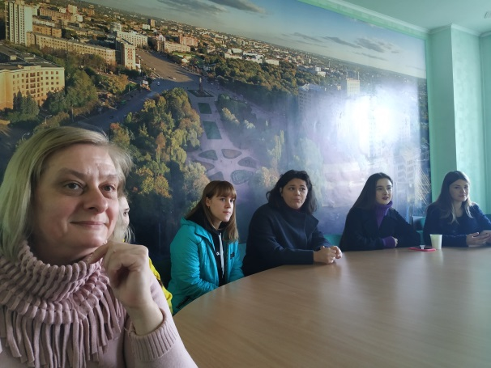

Conclusions:
- Summer school “WIN! Water Innovations Policy, Management, Research” was very valuable for participants and well-organised;
- Field trip was very interesting and useful as a practical part of the summer school;
- S.Burchenko will introduce new knowledge into her research;
- She has established new contacts those will be useful in her future carrier.

Information:
http://ecology.karazin.ua/mizhnarodna-dijalnist/intense-integrated-doctora/treningi/
http://ecology.karazin.ua/naukovij-seminar-po-rezultatam-litnoi-shkoli/

