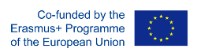
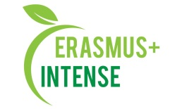

REPORT
on the workshop
Training “ICT tools and methods for curriculum development”

Date: 30 May 2019
Time: 15.00
Number of participants: 15 (registration list is attached)
Speakers: N. Maksymenko, A. Nekos, O. Chernikova

The aim of the workshop was presentation of the information on the training “ICT tools and methods for curriculum development” that was in Tartu, Estonia.
Target audience: PhD students and academic staff.

Speakers gave the information about the training, modern platforms those can be used in educational process for curriculum development. Special focus was made on experience and methods used in Estonian University of Life Sciences.
After presentation participants asked questions about speakers, skills obtained during the training and what options can be introduced into KKNU.

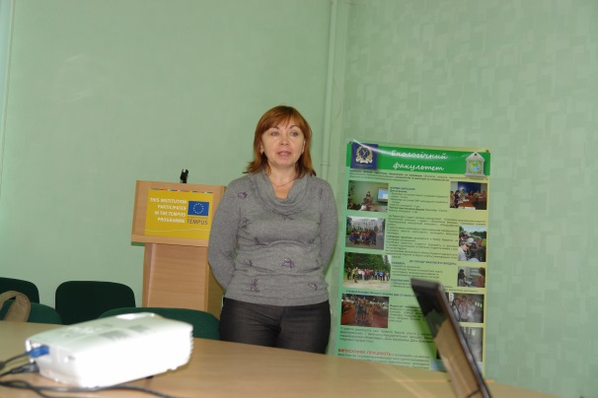 | 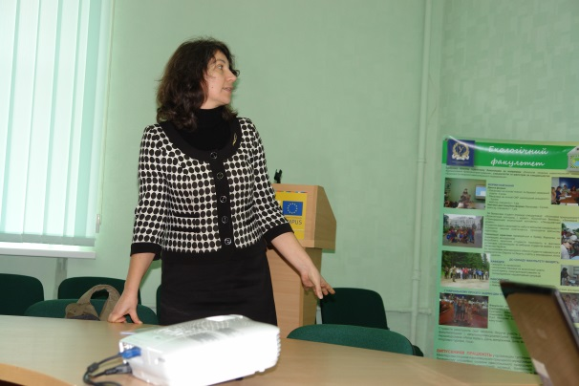
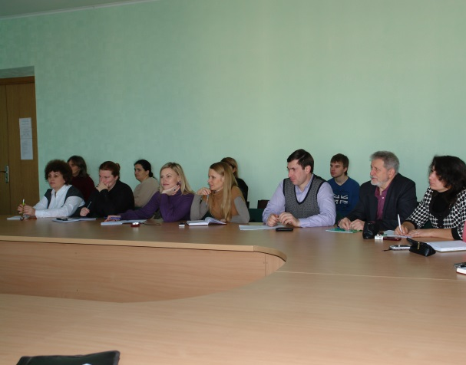

Conclusions:
- Modern education requires modern method and tools for curriculum development;
- e-learning will be widely used in EU and Ukraine in the nearest future;
- KKNU staff should continue improvement of their skills and knowledge on ICT tools and methods for curriculum development.

Information:
http://ecology.karazin.ua/mizhnarodna-dijalnist/intense-integrated-doctora/treningi/
http://ecology.karazin.ua/vidbuvsja-naukovo-metodichnij-seminar/

