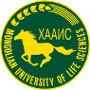

THE NATIONAL INTENSE PROGRAM IN MONGOLIA
INTENSE – Integrated Doctoral Program for Environmental Policy, Management and Technology

THE SETTLED NOMADISM-2021
SUMMER SCHOOL PROGRAM OF ENVIRONMENTAL SCIENCES
REPORT
Background information:
The INTENSE national agreement between Mongolian partners has been signed on 26th April 2019. The objective of the agreement is to establish and to strengthen the INTENSE national program for graduate study. The INTENSE national program partners of National University of Mongolia (NUM), Khovd State university (KHU), and Mongolian University of Life Science (MULS) have been jointly organized the Summer school of environment and its monitoring at the Khovd aimag, Mongolia between 16-29 August 2021. The school was bring together researchers and professionals from respectable Mongolian universities and stakeholders from the western Mongolian region to discuss environmental monitoring in research and applications. The summer school was eligible for graduate students of NUM, KHU and MULS to learn about the research method and trends in these and related fields. Upon completion of the summer school, the graduate students gained a knowledge of semi-desert and wetland ecology, high mountain environment and special protected area management in the western region of Mongolia from national scientists experienced in aforesaid studies. Furthermore, students were experienced western Mongolian culture traditions, and nomadic herding lifestyle, production of milk products, national songs and music. Students stayed in a ger, Mongolian traditional accommodation in natural beautiful places.
The organizing committee:
- Professor Ochir Altansukh, NUM
- Associate professor Baku Bayarhuu, KhU
- Associate professor Dugarjav Delgerjargal, MULS
Preparation:
During the annual meeting of the INTENSE program in Mongolia which was held in Ulaanbaatar between 17 June and 24 June 2021, initial idea to organize the summer school is discussed. Then national coordinator of the project professor O.Altansukh visited KHU in Khovd and jointly developed full program of “The settled nomadism-2021” summer school of environmental sciences, and visited several places to check availability for the summer school. Full program of the summer school can see Attachment 1.
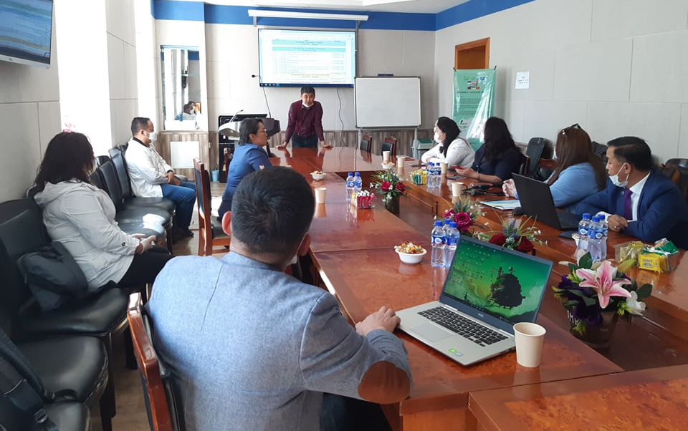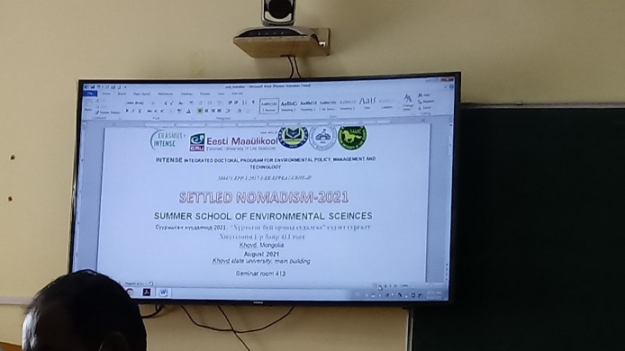
Announcement:
The summer school has been announced via the official website of NUM on 5 August 2021. Before that, verbal announcement has been spread.
https://news.num.edu.mn/?p=84503
http://seas.num.edu.mn/article/237/2021
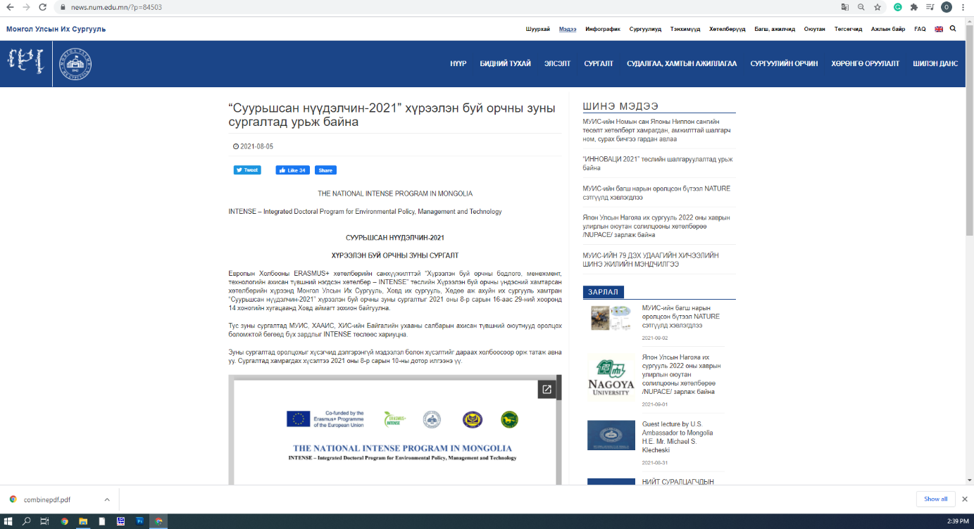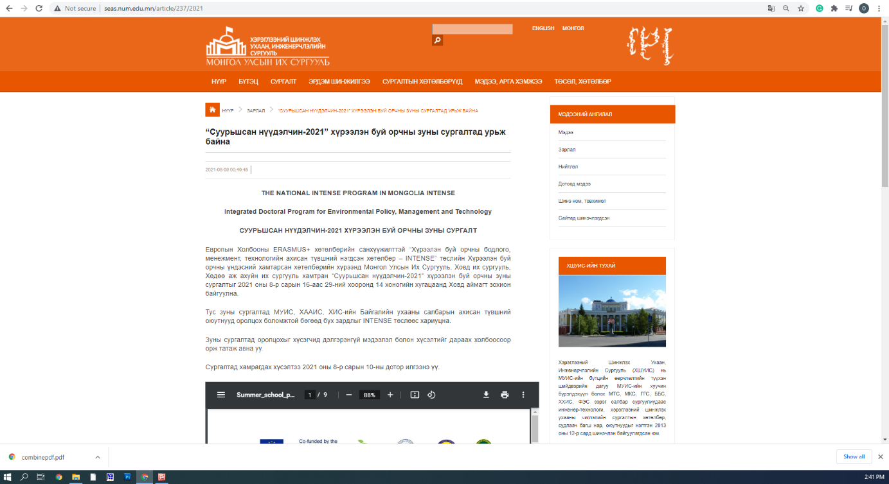

Registration and selection:
The summer school was open to graduate students (preferable to PhD students) of National University of Mongolia (NUM), Khovd State university (KHU), Mongolian University of Life Science (MULS), who are involved in environment-related sciences. Registered participants were selected by the NUM, KHU, MULS committee based on their merits, educational and research background and other criteria. Selected participants were informed of their acceptance by 12th August 2021.
The selection was carried out by the organizing committee on the basis of the received documents and interview with candidates. The interview carried out on 12th August 2021 via Google meeting. The Commission was evaluated each candidate by 1-10 points. The list of selected participants were notified with an email on 12th August 2021.

Duration: 14 days (16th August – 29th August, 2021)

Fees: All cost was covered by the INTENSE project.

COVID-19 vaccination:
The participants shown the vaccination certificate that shows all 2 doses of any type of vaccination and passed more than 14 days or sick and treated certificate that proves participants get sick by COVID and treated.

Insurance:
All participants have been insured by the local insurance company Mandal. Attachment 2.

Participants:
In total, 7 students and 10 staffs were participated the summer school.
№ | Name of the participants | University | Level of study/staff
1 | O.Altansukh | NUM | Staff
2 | N.Oyunchimeg | NUM | Staff
3 | T.Narmandakh | NUM | Staff
4 | B.Bayarmaa | NUM | PhD student
5 | D.Erdenerjargal | NUM | MSc student
6 | D.Narmandakh | NUM | MSc students
7 | B.Bayarkhuu | KHU | Staff
8 | E.Amarjargal | KHU | Staff
9 | N.Tegshjargal | KHU | Staff
10 | B.Gantumur | KHU | Staff
11 | A.Amarjargal | KHU | Staff
12 | D.Otgonbayar | KHU | Staff
13 | D.Darikhand | KHU | Staff
14 | D.Enkhtuul | KHU | Ph.D student
15 | Ts.Nyambayar | KHU | Ph.D student
16 | B.Nandintsetseg | KHU | Ph.D student
17 | M.Bayarmaa | KHU | MSc student

Day to day activity:
The first day (16 August 2021) – Travel:
Due to very limited flight to Khovd from Ulaanbaatar, NUM participants decided to rent two vehicles to go Khovd. The first day of the summer school, the participants departure Ulaanbaatar, and drove 12 hours along 750 km. We took rest in ger in Bayankhongor aimag.
The second day (17 August 2021) – Arrival:
We travelled to Khovd from Bayankhongor aimag for 10 hours along 700 km, and arrived Khovd aimag around 5 pm. The participants stayed at Steppe hotel.

The third day (18 August 2021) – University:
At 9 am, all participants were gathered at Khovd State University and introduced themselves. As it was planned, several lectures and introduction were given by professors D.Unursaikhan, B.Bayarkhuu, O.Altansukh and D.Delgerjargal. Most importantly, the INTENSE national program and the summer school were broadly introduced to participants.
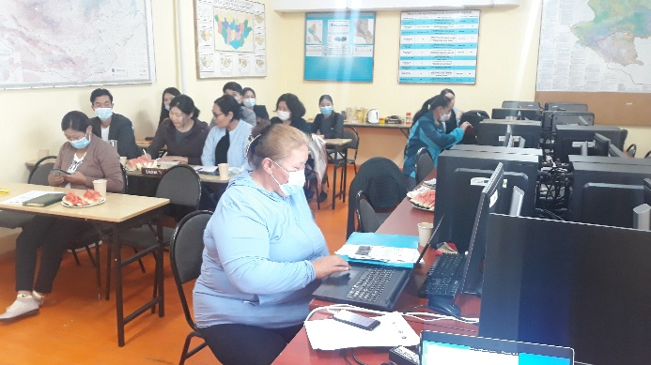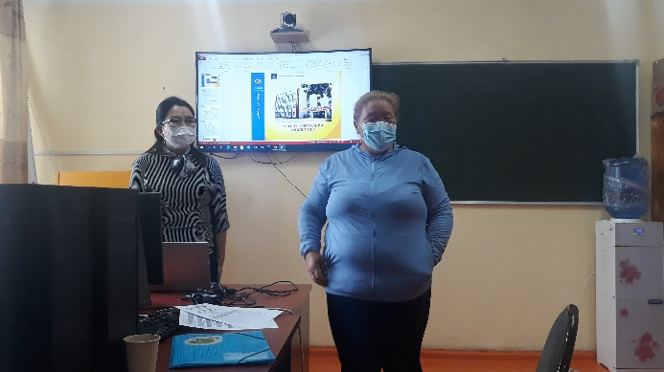
The fourth day (19 August 2021) – Khovd city:
After the lecture about coal industry and its impact on environment by professor B.Gantumur, we visited field camp of KHU, and the summer school was continued at plant study area. In afternoon, the participants went to weather station of Khovd city and learnt how to install weather instruments, how to measure weather parameters, how weather data is produced.
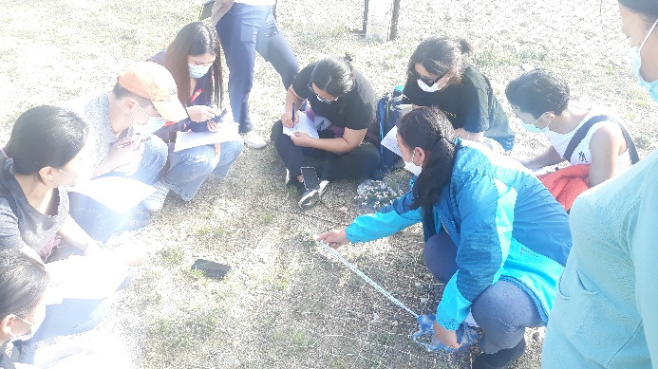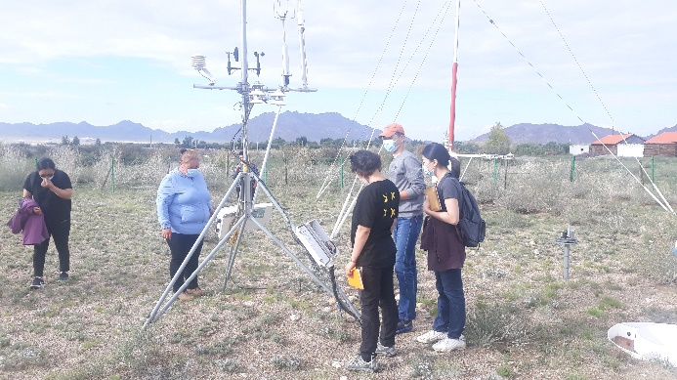
The fifth day (20 August 2021) – Khar Us Lake national park:
Next day, we went to Khar Us Lake national park. We visited wetland monitoring place and bird watching tower. Professor Z.Burmaa gave us lecture and field exercise for half day.
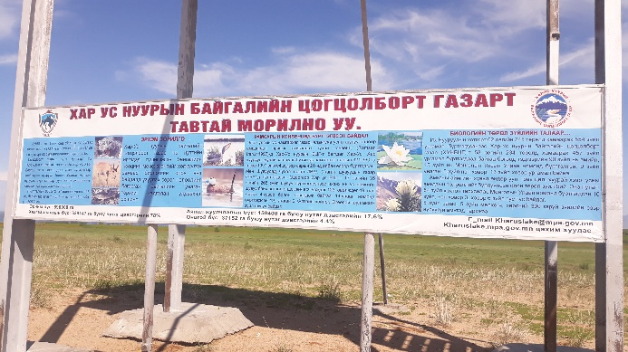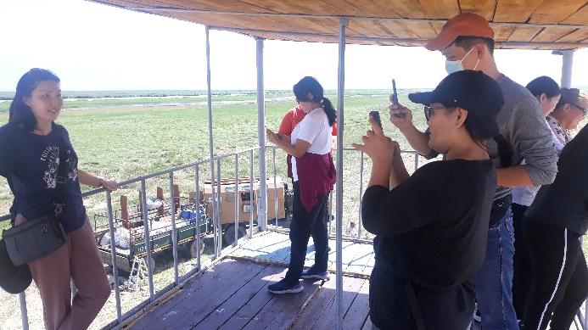
The sixth day (21 August 2021) – Durgun hydropower station:
Due to COVID restriction at Durgun hydropower station, we could not enter the station. However, the summer school continues near the Khovd River, where Erdeneburen hydropower station will be built. A lecture “Renewable energy and its impact on environment” given by professor O.Altansukh and hydrological regime of high mountain region was explained by professor D.Otgonbayar.
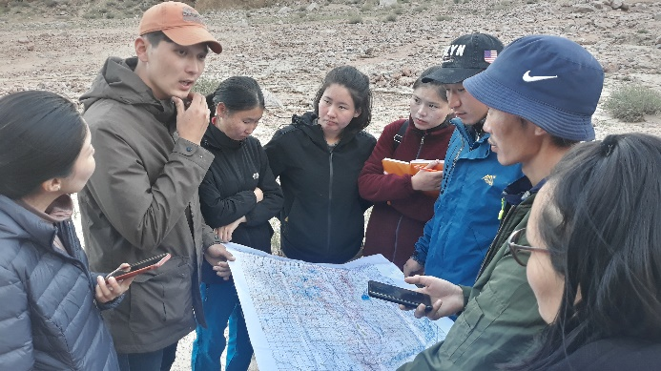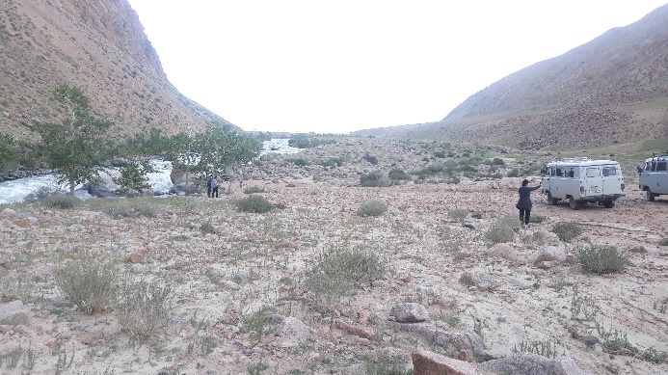
The seventh and eight days (22-23 August 2021) – Myangan Ugalzat national park:
According to the agenda, the summer school continued in Myangan Ugalzat national park. Protected area management issues and high mountain flora lectures and exercises given by professors N.Oyunchimeg and D.Darikhand. After lectures, field study to observe and identify plant species was organized.
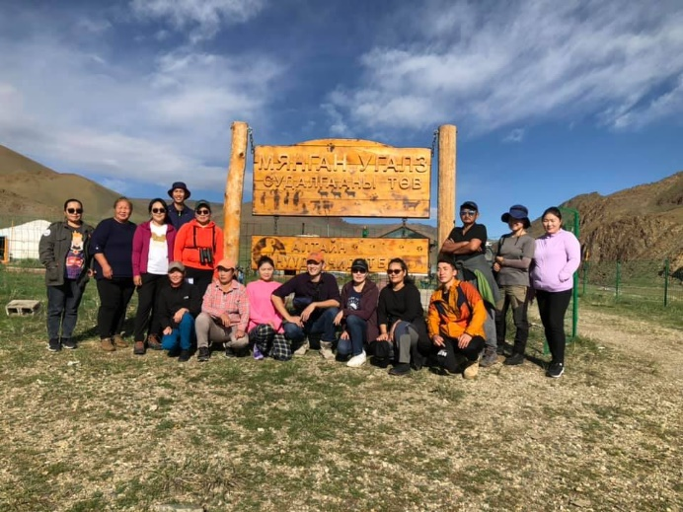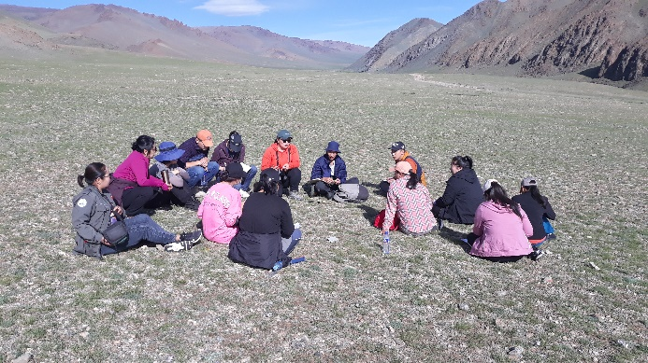
The nineth and tenth days (24-25 August 2021) – Munkh Khairkhan national park:
Due to heavy rain near Tsambagarav National Park, some dirt road was broken. Therefore, we changed destination and went to Munkh Khairkhan national park to continue our summer school. Next days, lectures about high mountain environment, eternal snow, glacier and climate change impact on high mountain are given by professor D.Otgonbayar. Walking tour to glacier, weather station at high mountain was organized for full day.
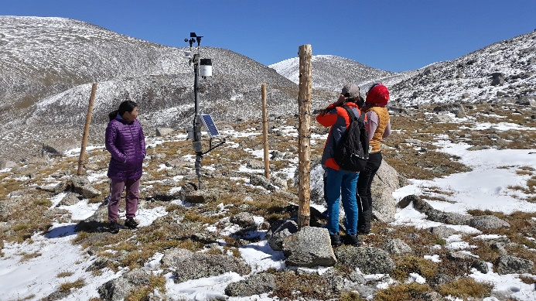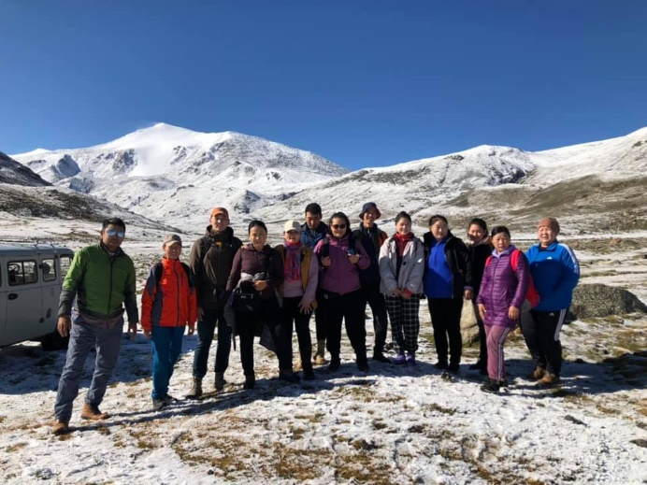
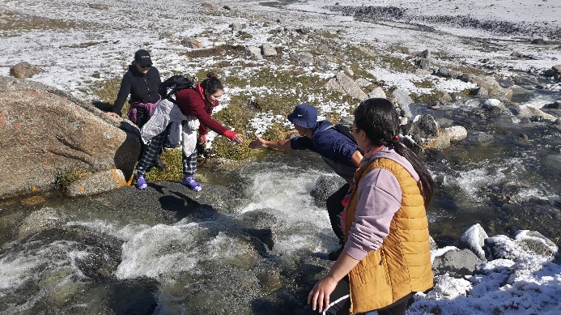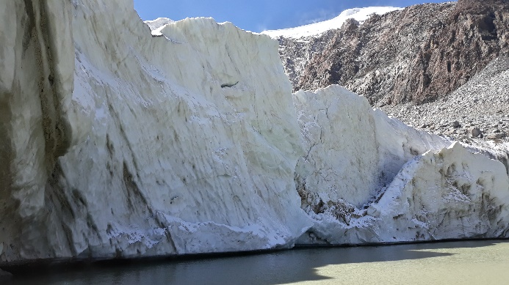
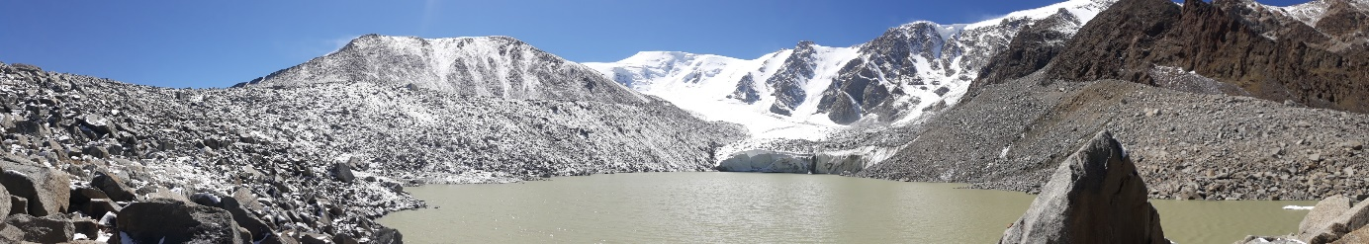
The 11th day (26 August 2021) – Back to Khovd city and WWF office:
Next day, we went back to Khovd city and afternoon we listened very interesting lecture about high mountain animals, the snow leopard that given by WWF officer O.Munkhtogtokh.
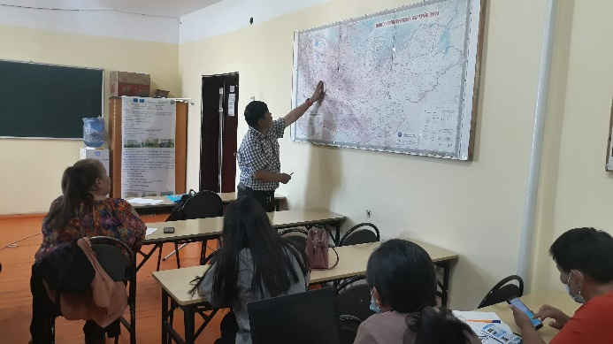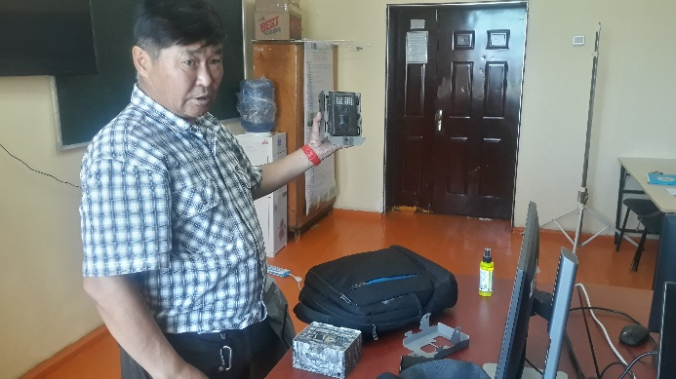
The 12th day (27 August 2021) – Wrap-up and student presentation:
In the morning, all students and staffs were divided into two groups and worked on presentation about what they learnt during the summer school. In the afternoon, the groups presented their presentations, and professors were asked some questions. After presentation, the summer school officially closed and certificates were given.
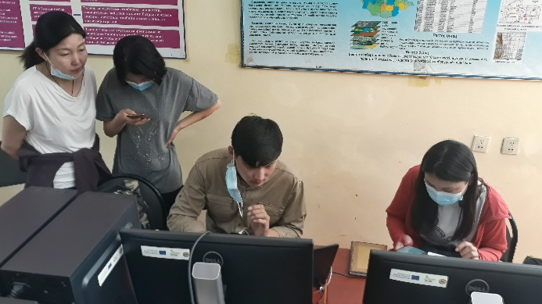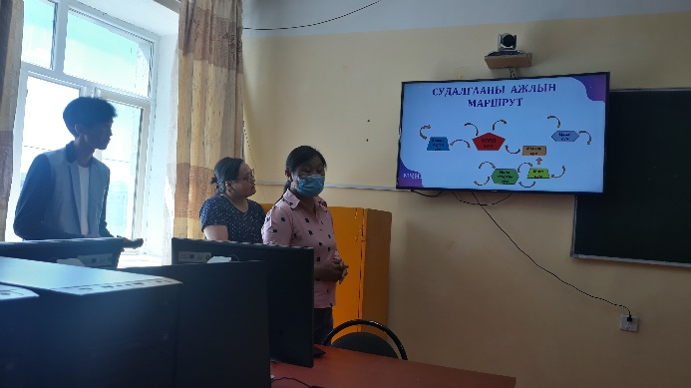
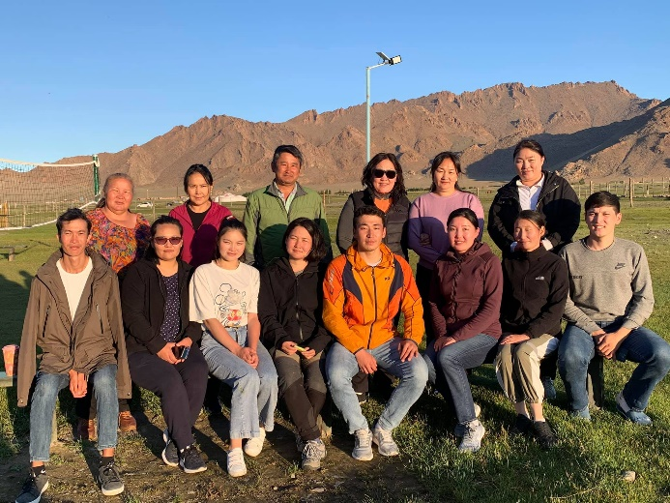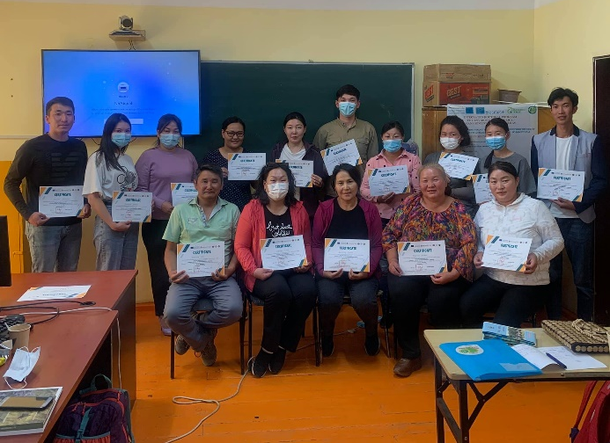
The 13rd and 14th days (28-29 August 2021) – Back to UB:
After very successful organization of the summer school, NUM participants went back to Ulaanbaatar city for 2 days along 1450 km asphalt and dirt road.

Certificate
Upon the successful completion of the program, all participants handed over certificates of the summer school. Attachment 3.

Conclusion:
The summer school of the INTENSE national program, entitled “The settled nomadism-2021” was jointly organized by Mongolian partner universities NUM, KHU and MULS between 16 and 29 August 2021 for 14 days in Khovd aimag, Mongolia. In total, … students and … staffs were participated. During the summer school, we visited natural zones such as wetland, lake and high mountain area. Students were learnt about plant monitoring, high mountain biodiversity, climate change impact on eternal snow and glacier, wetland study, renewable energy and its impact on environment and special protected area management.
Students’ impression about the summer school is readable on Attachment 4.

Appendix 1: The summer school program
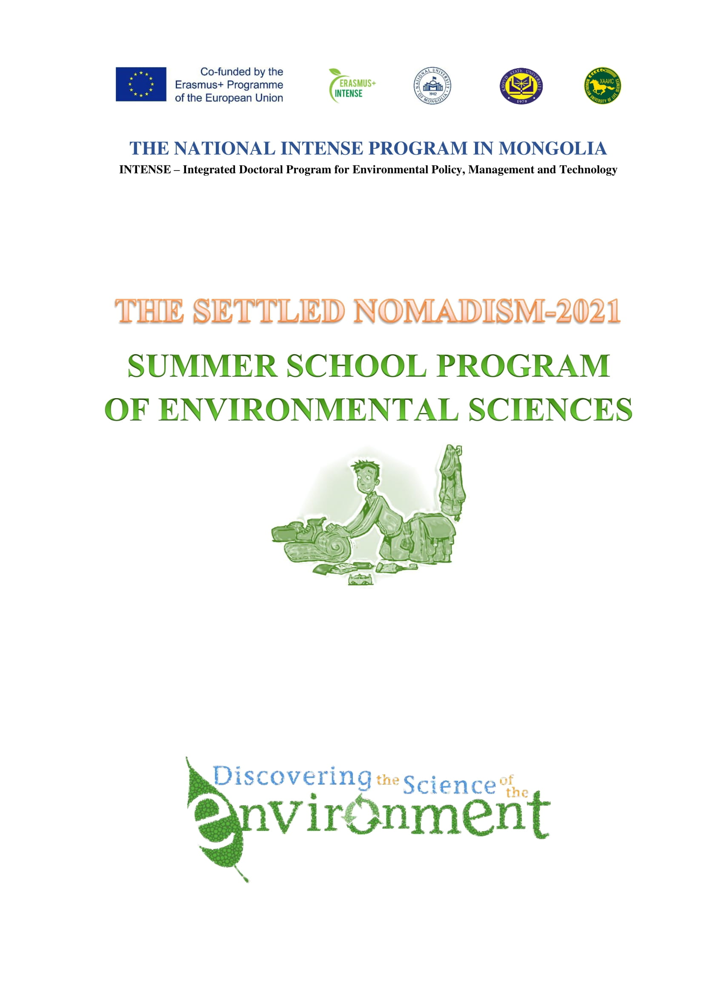
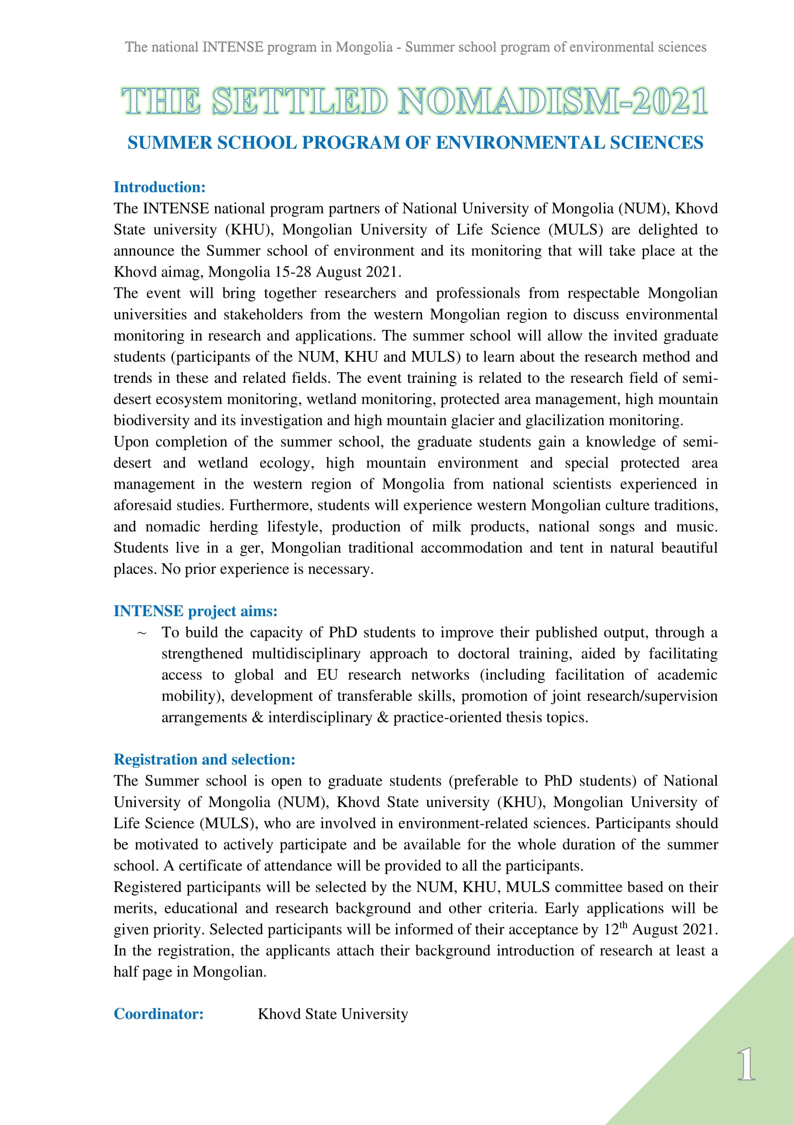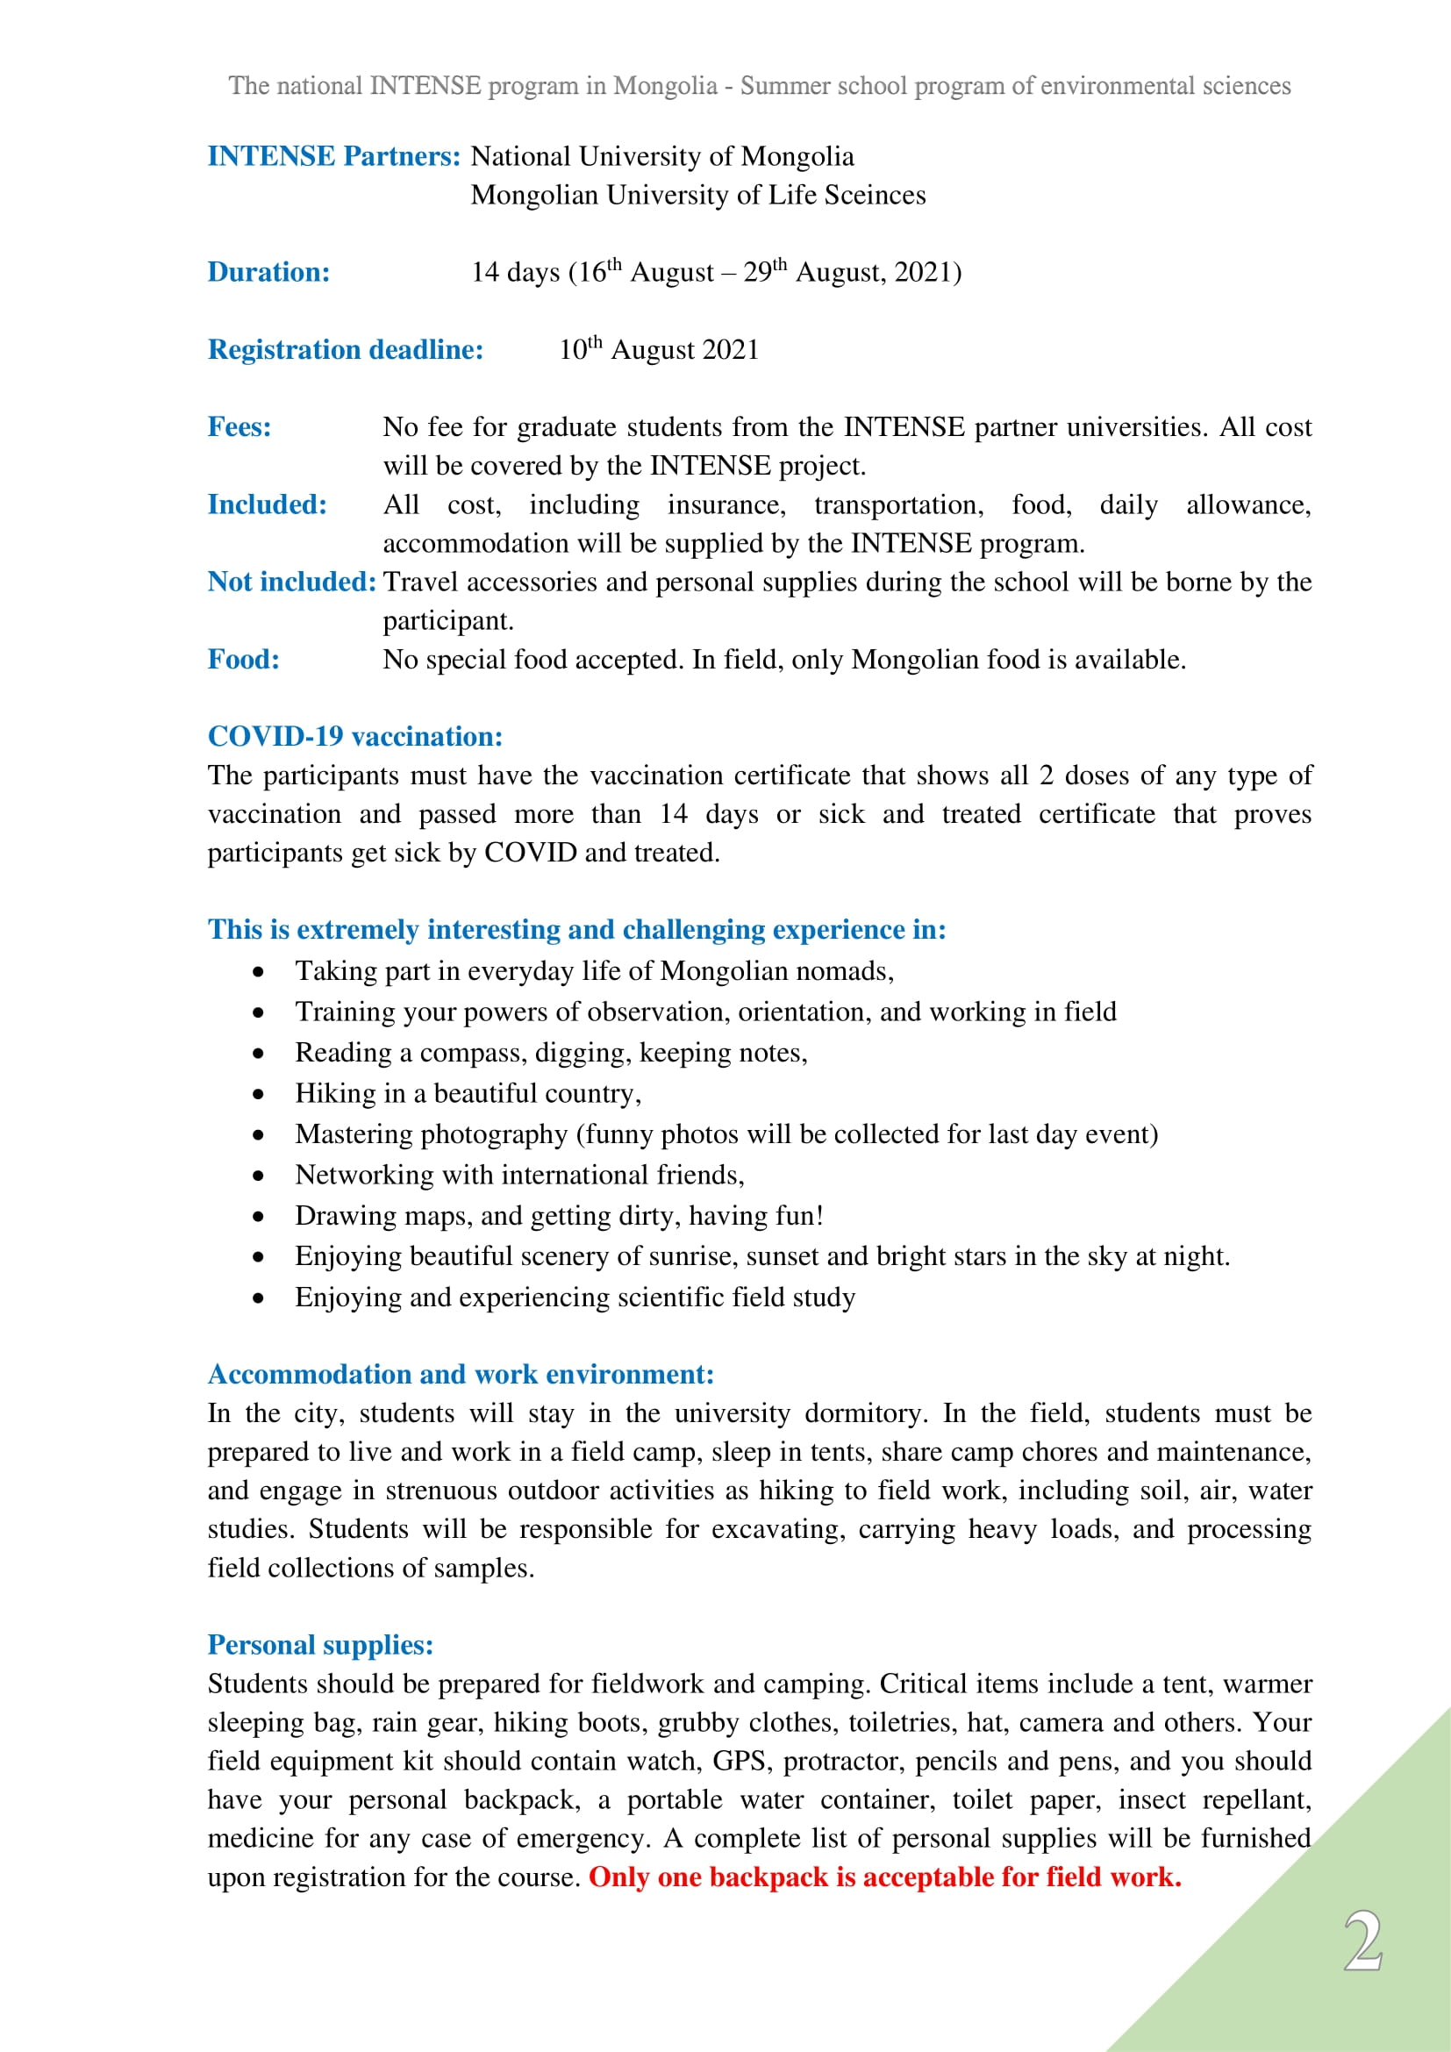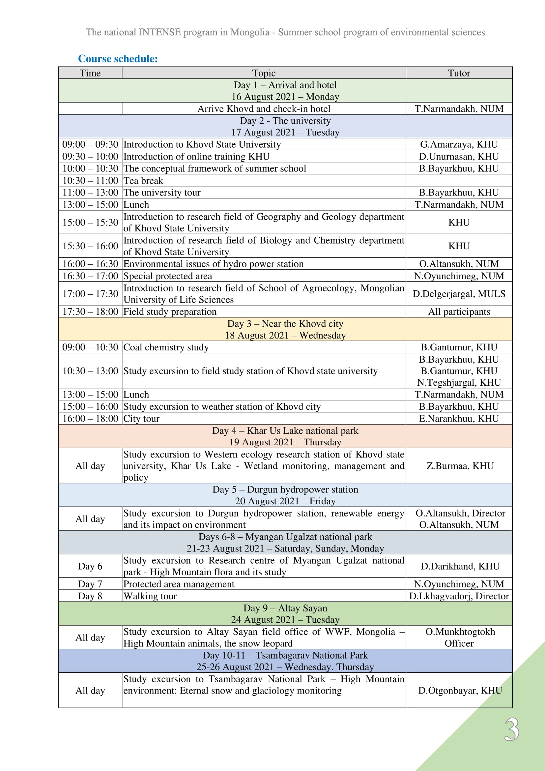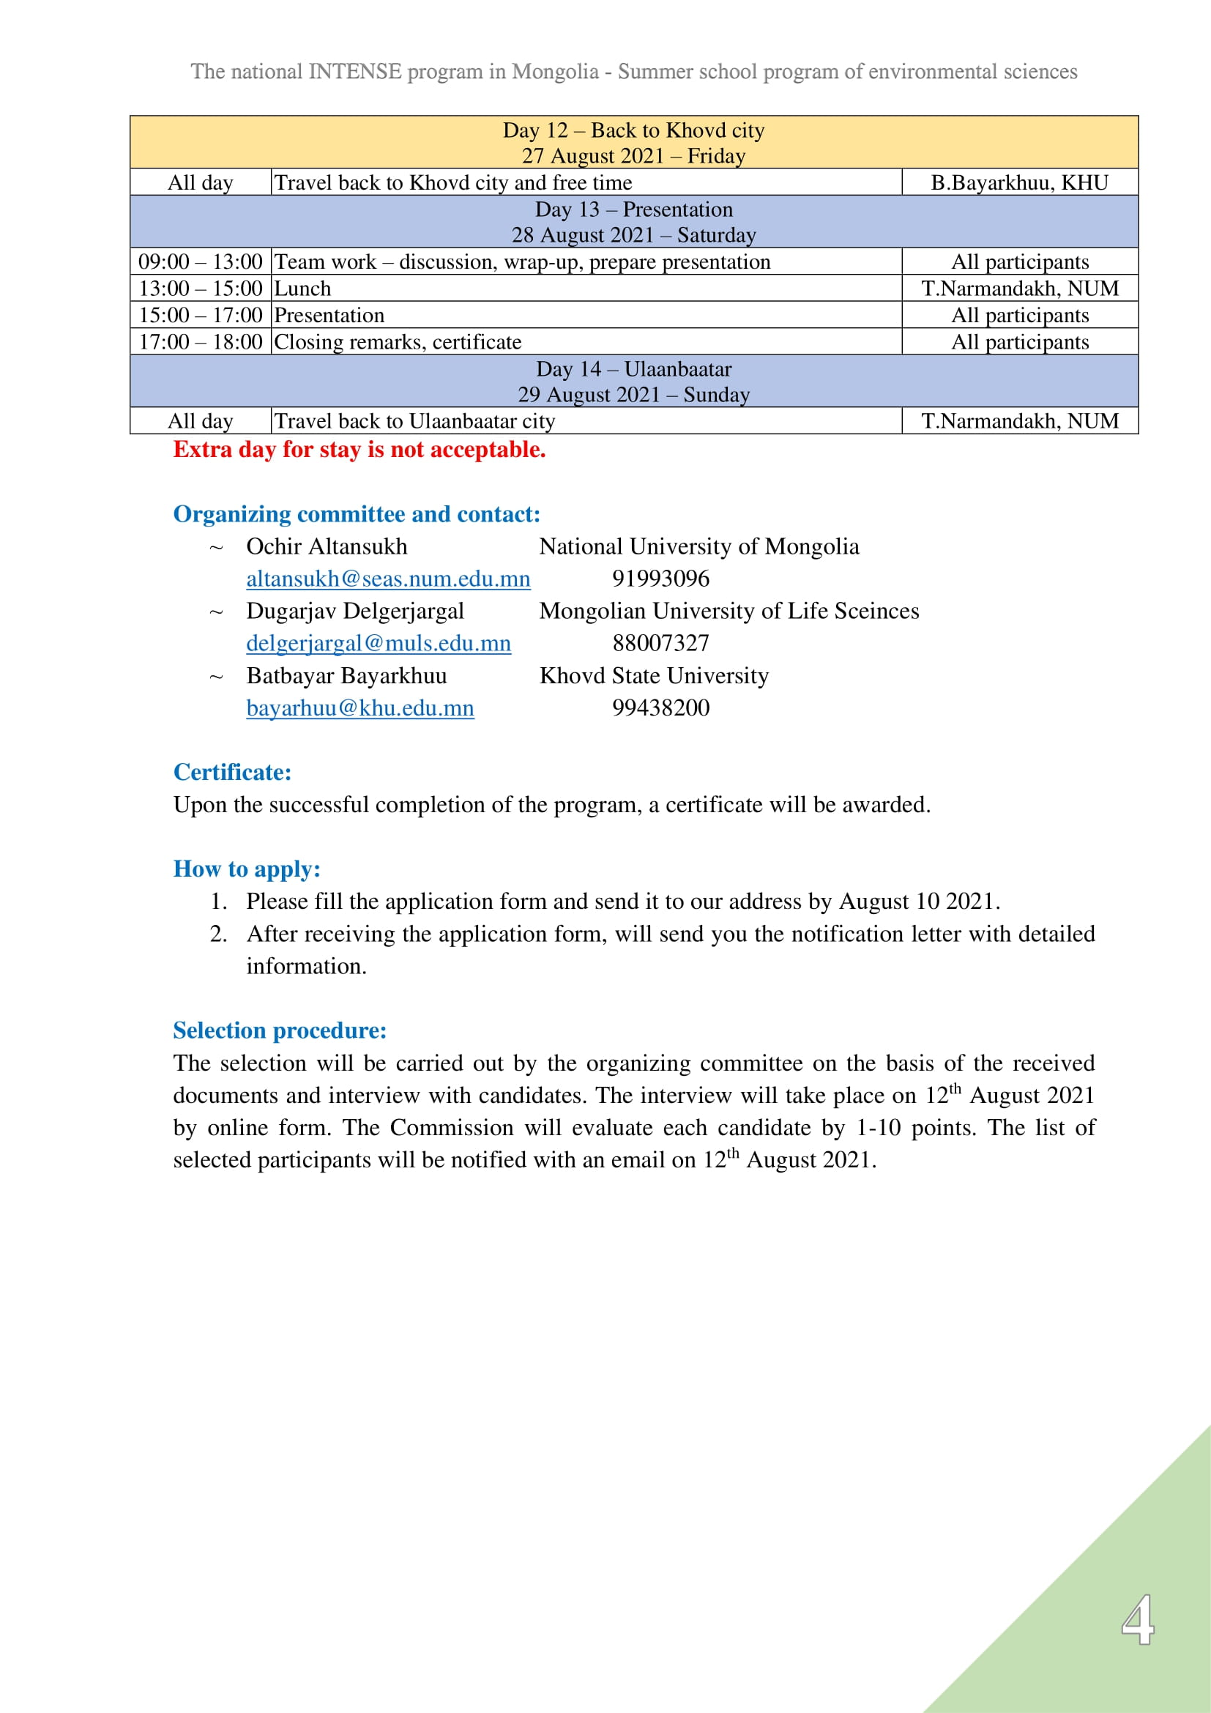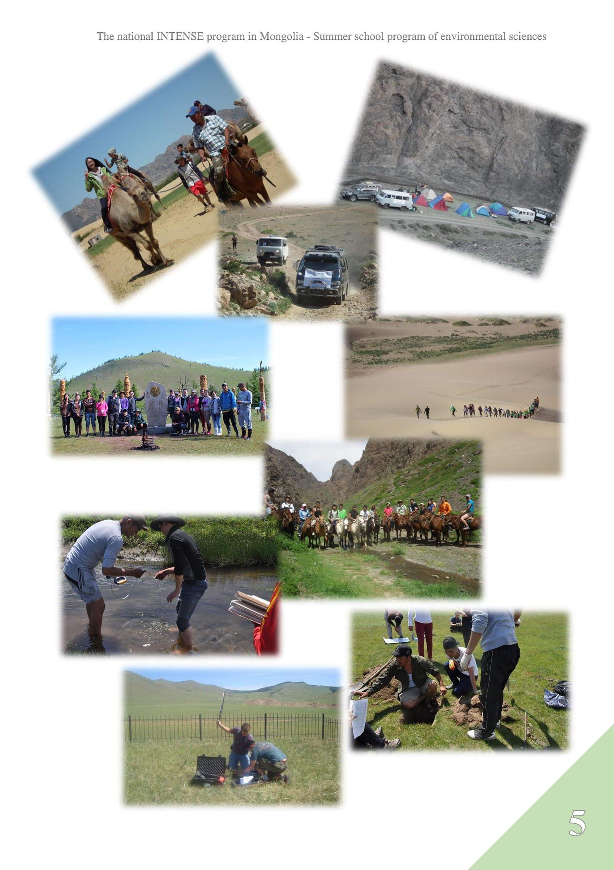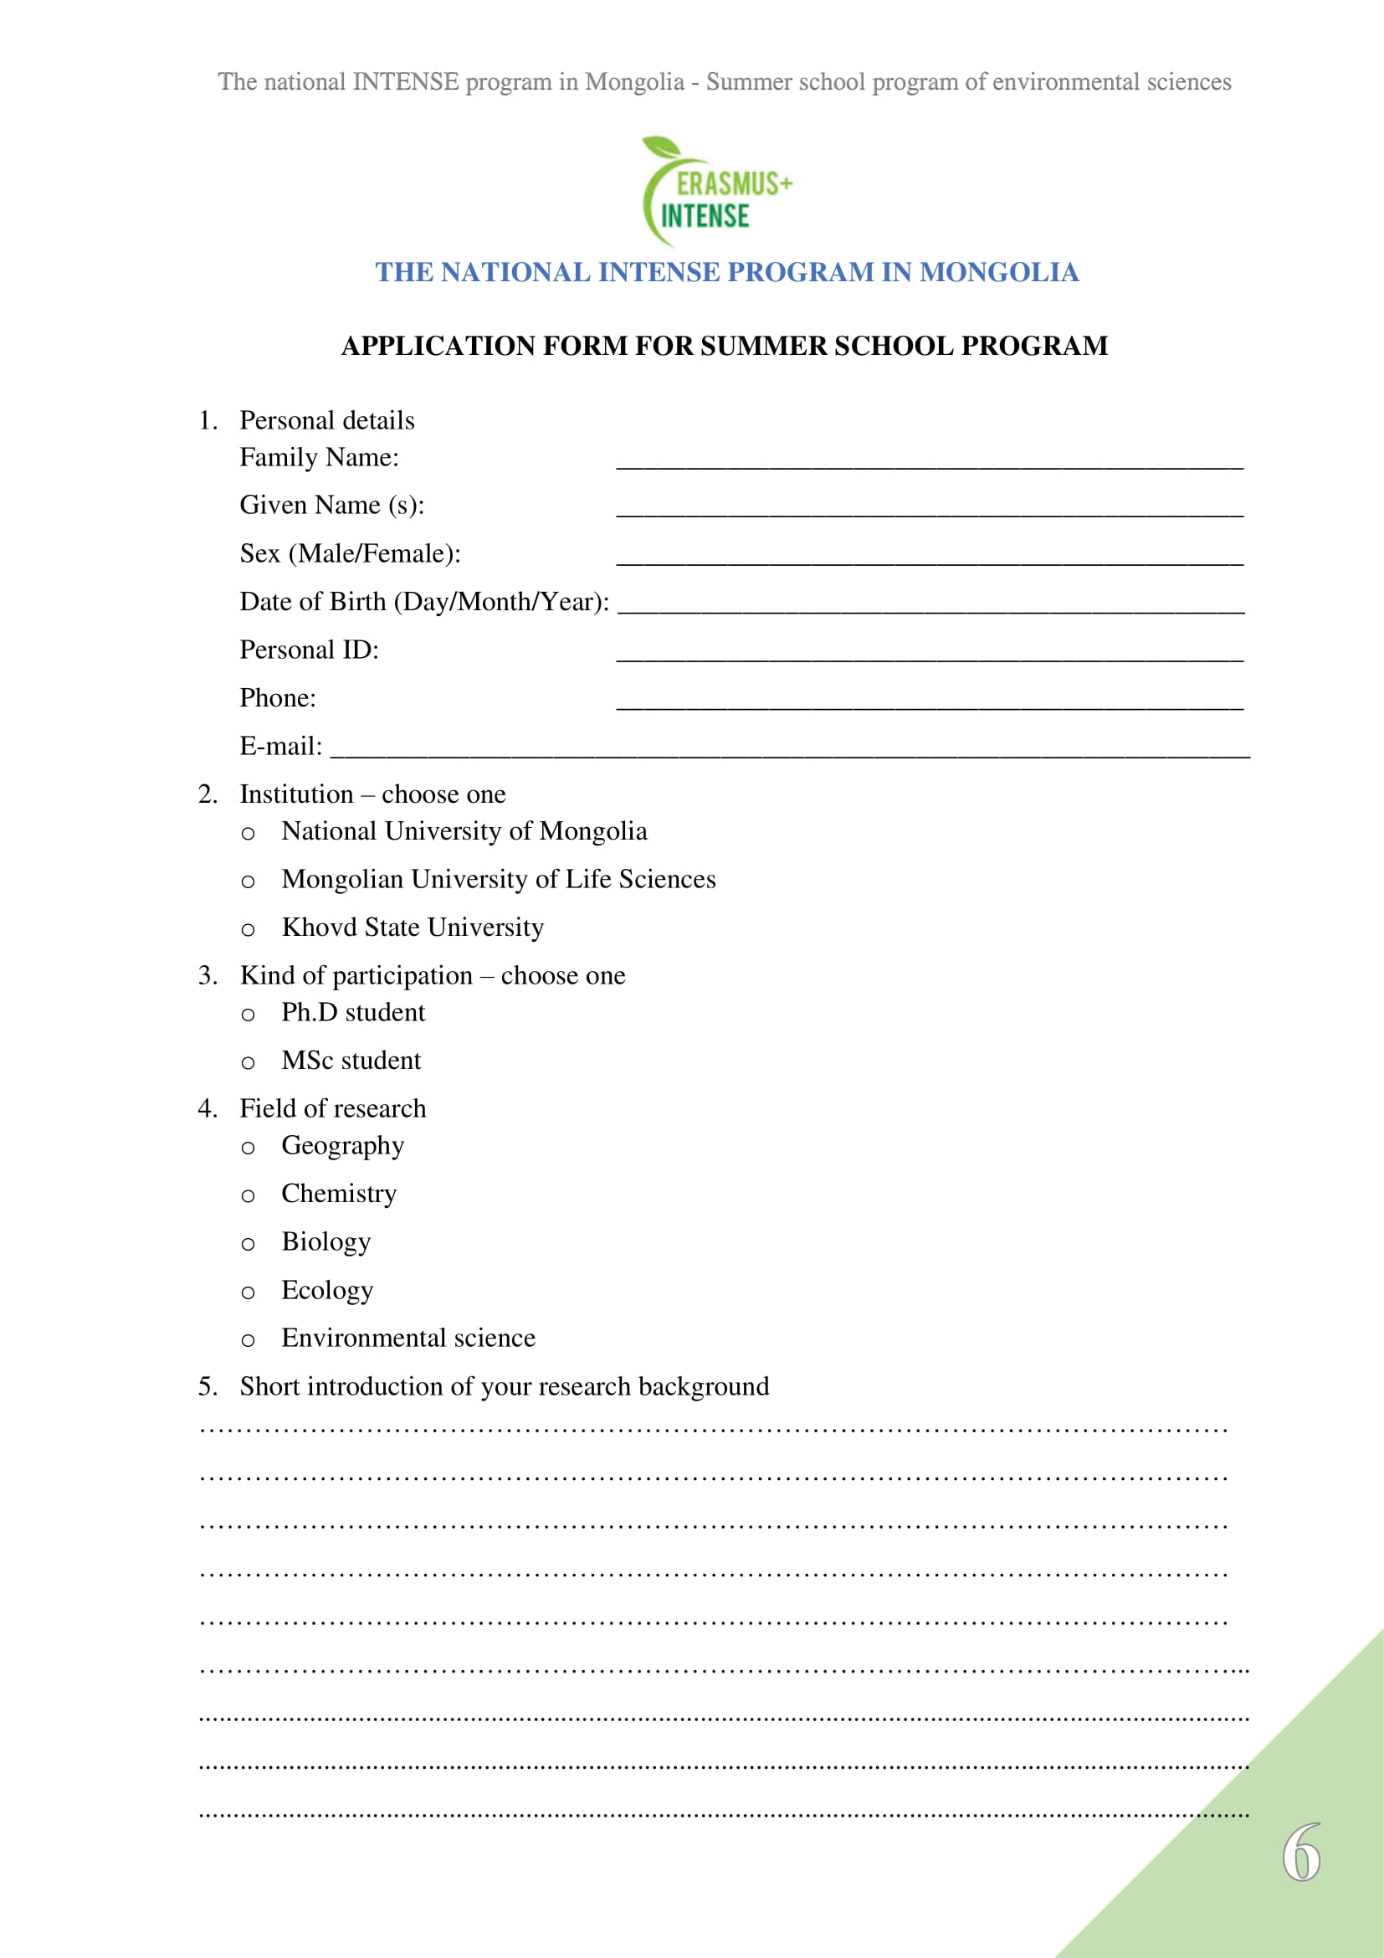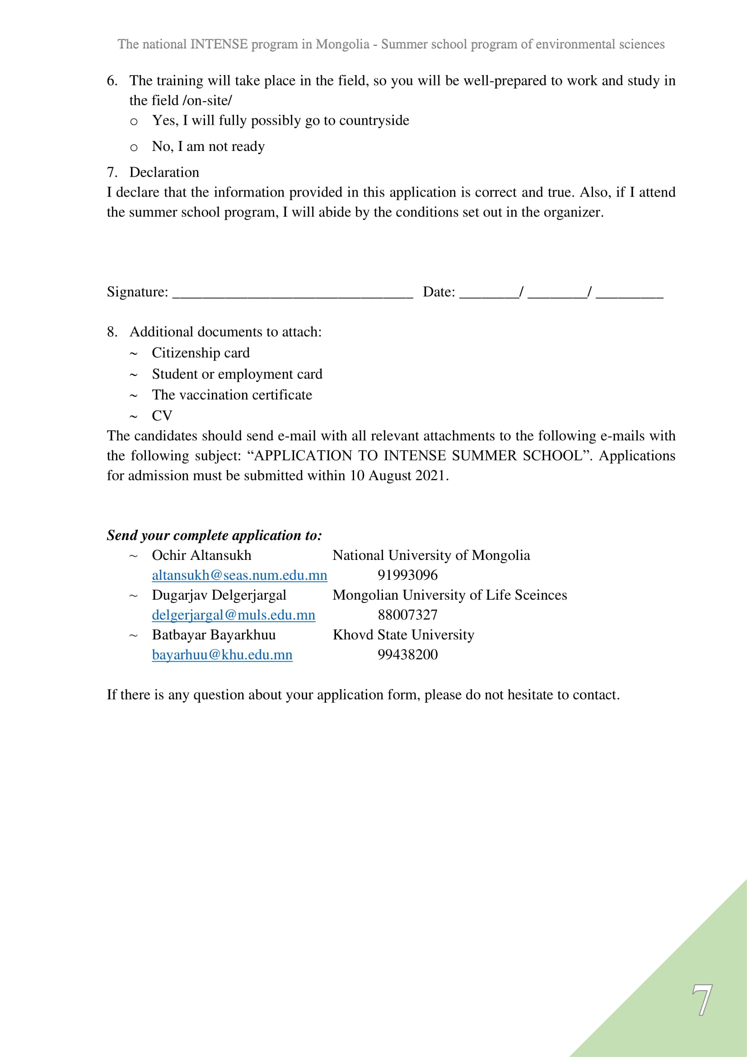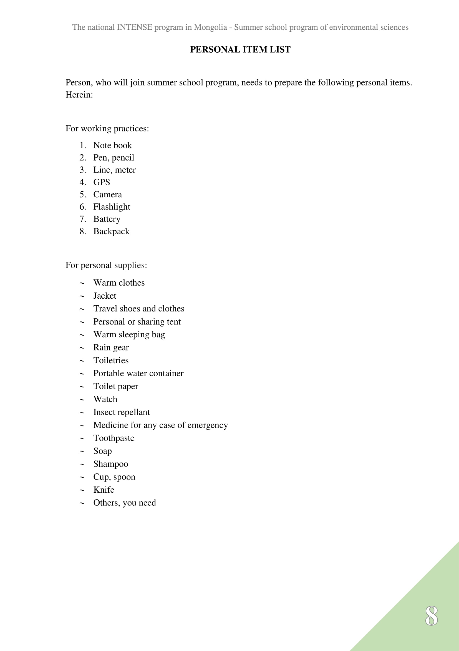

Appendix 2: Travel insurance
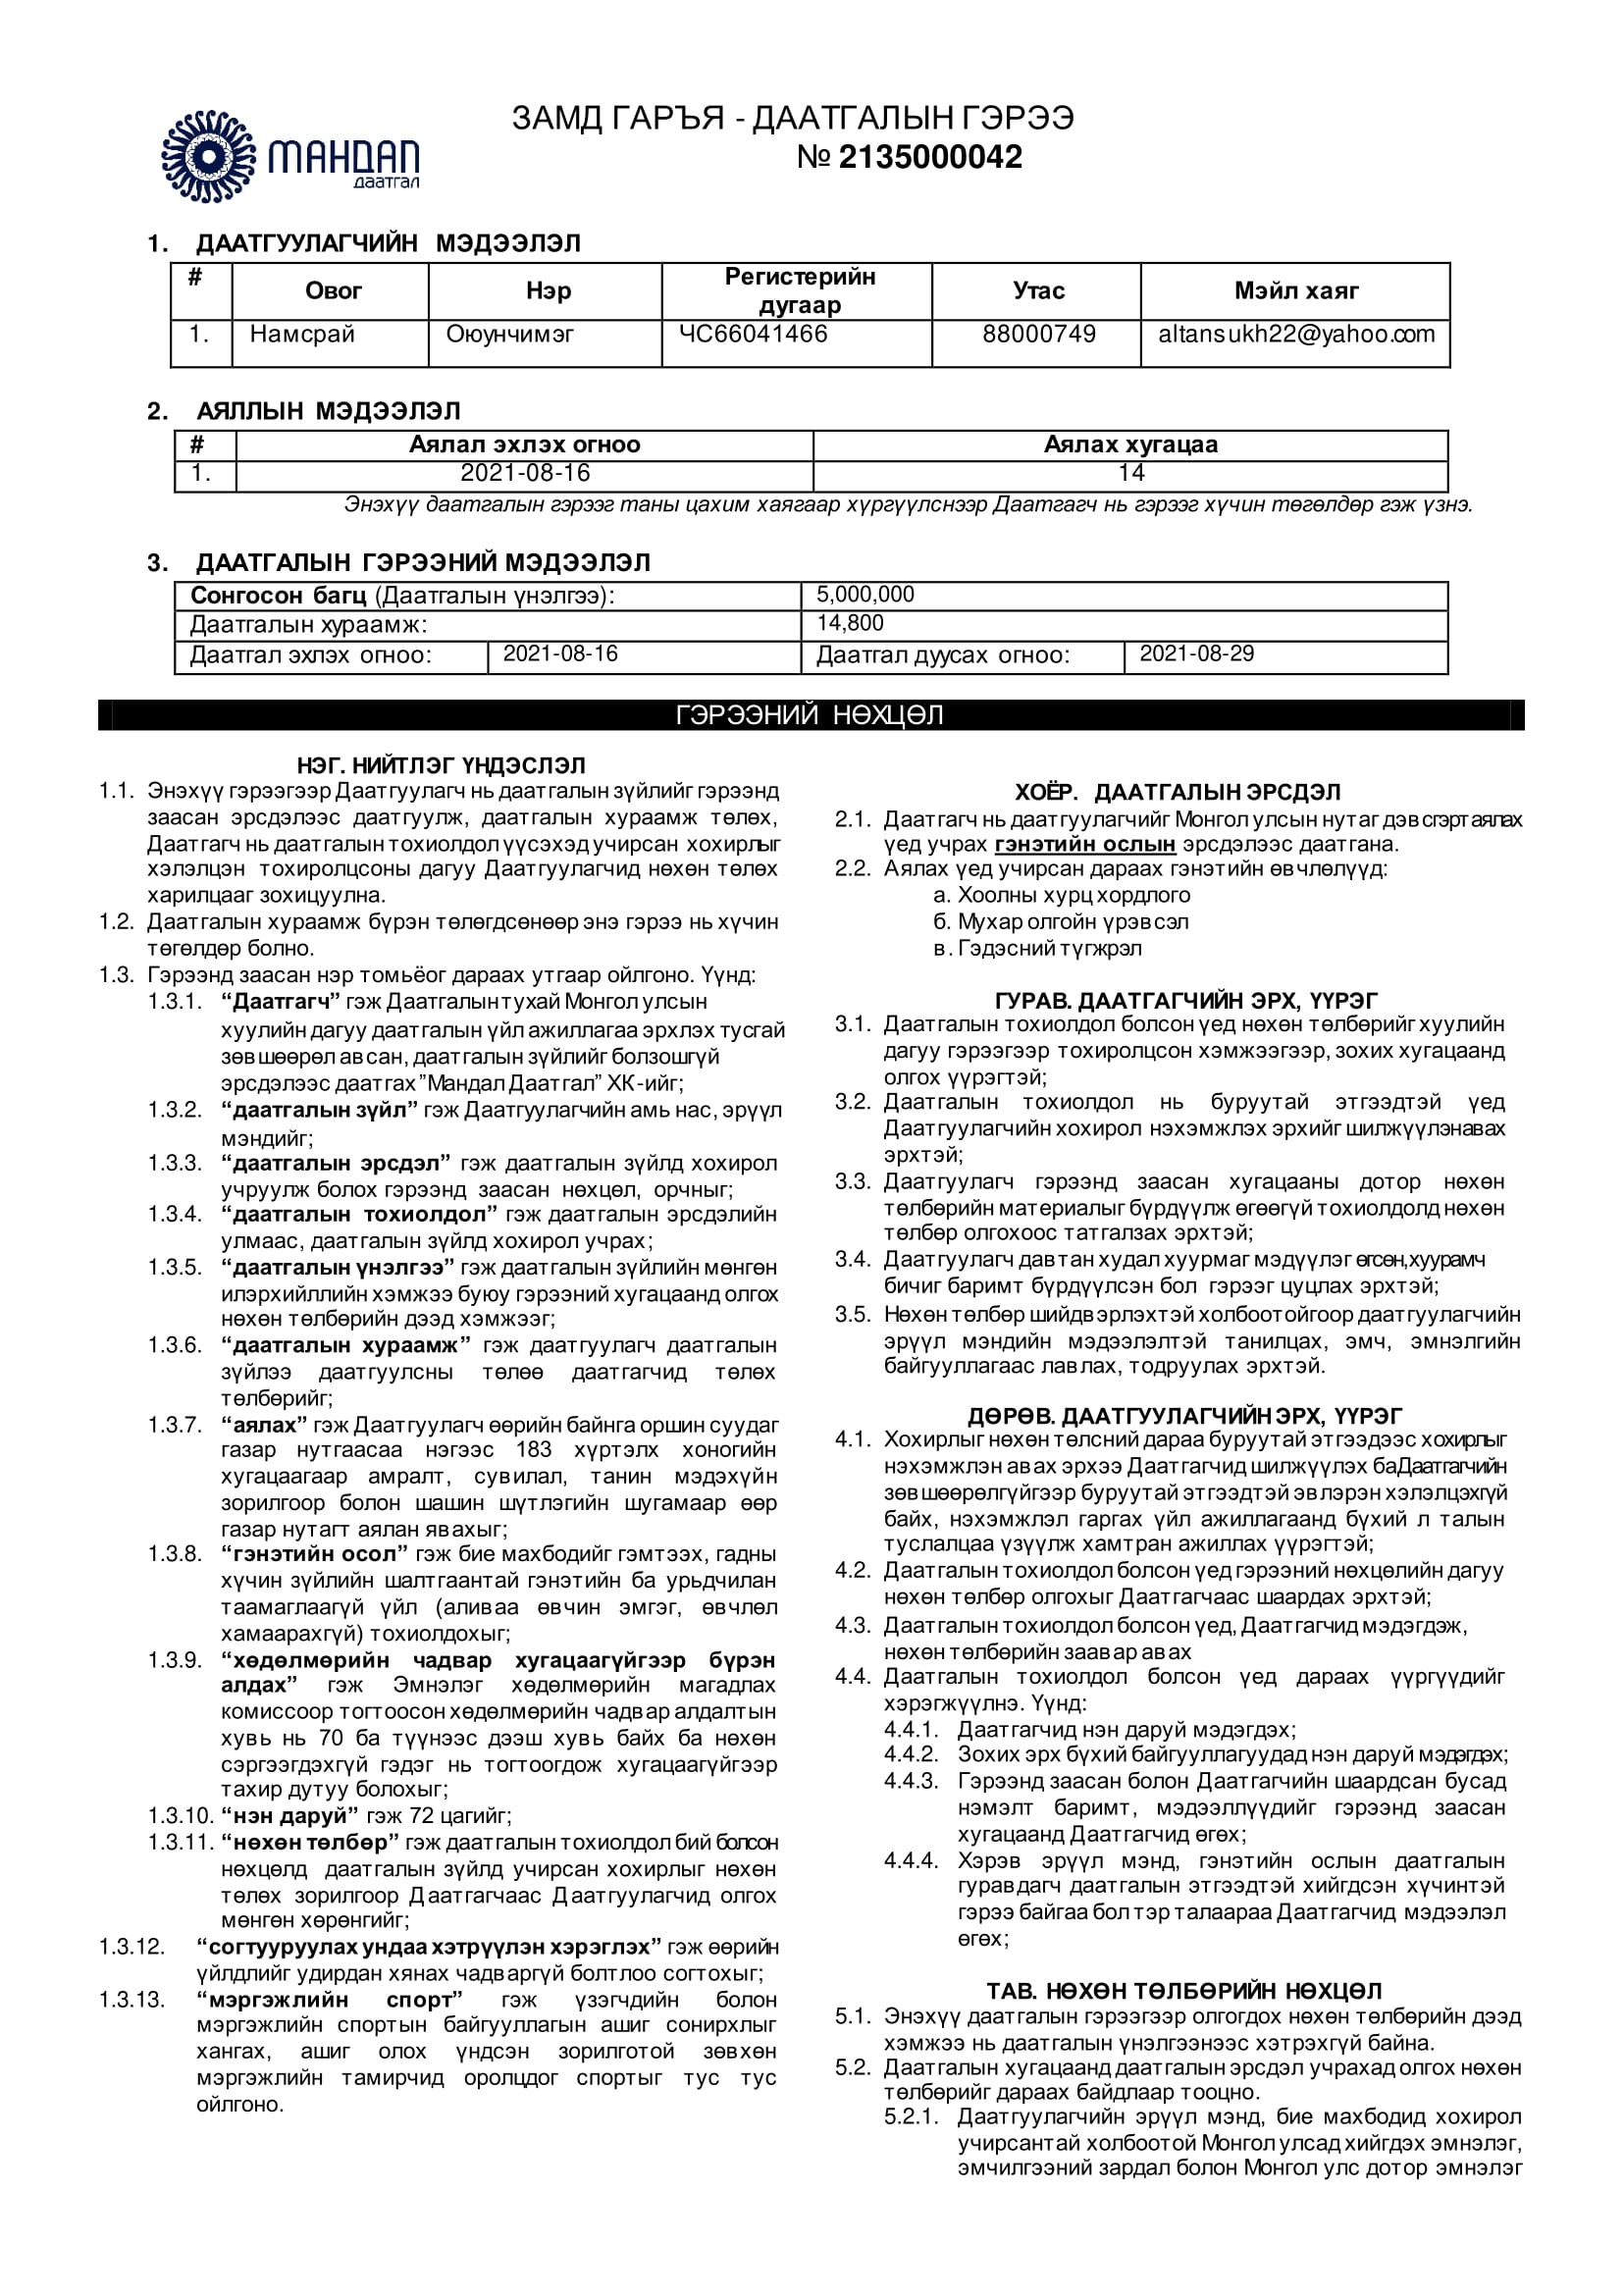
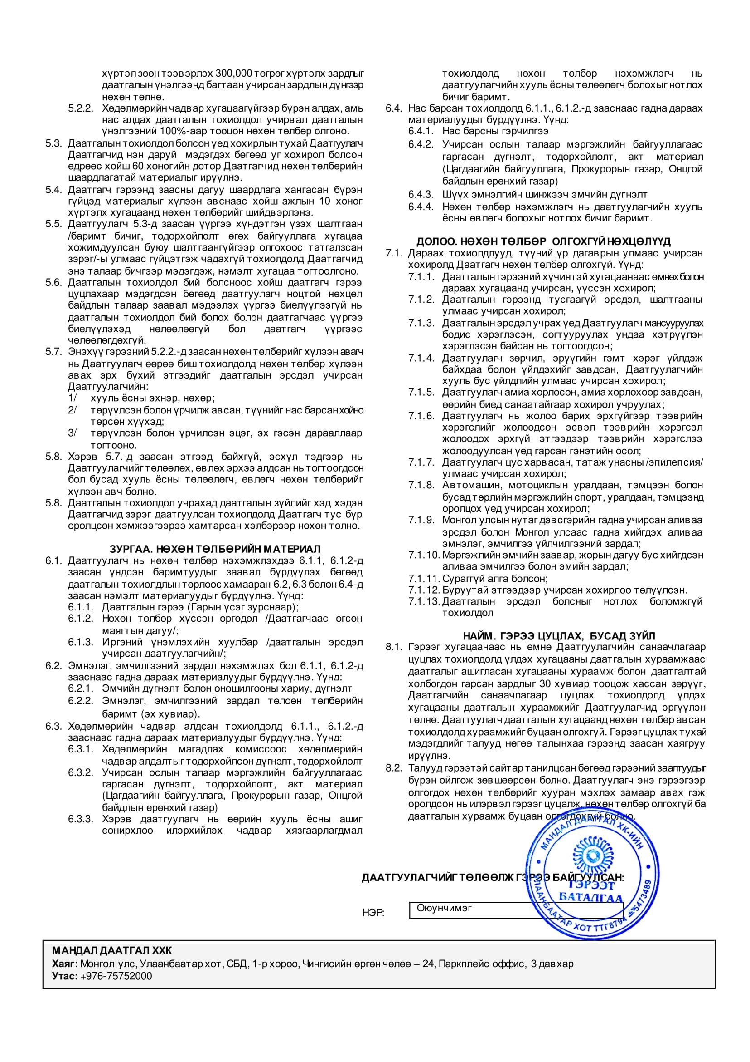

Appendix 3: The summer school certificate

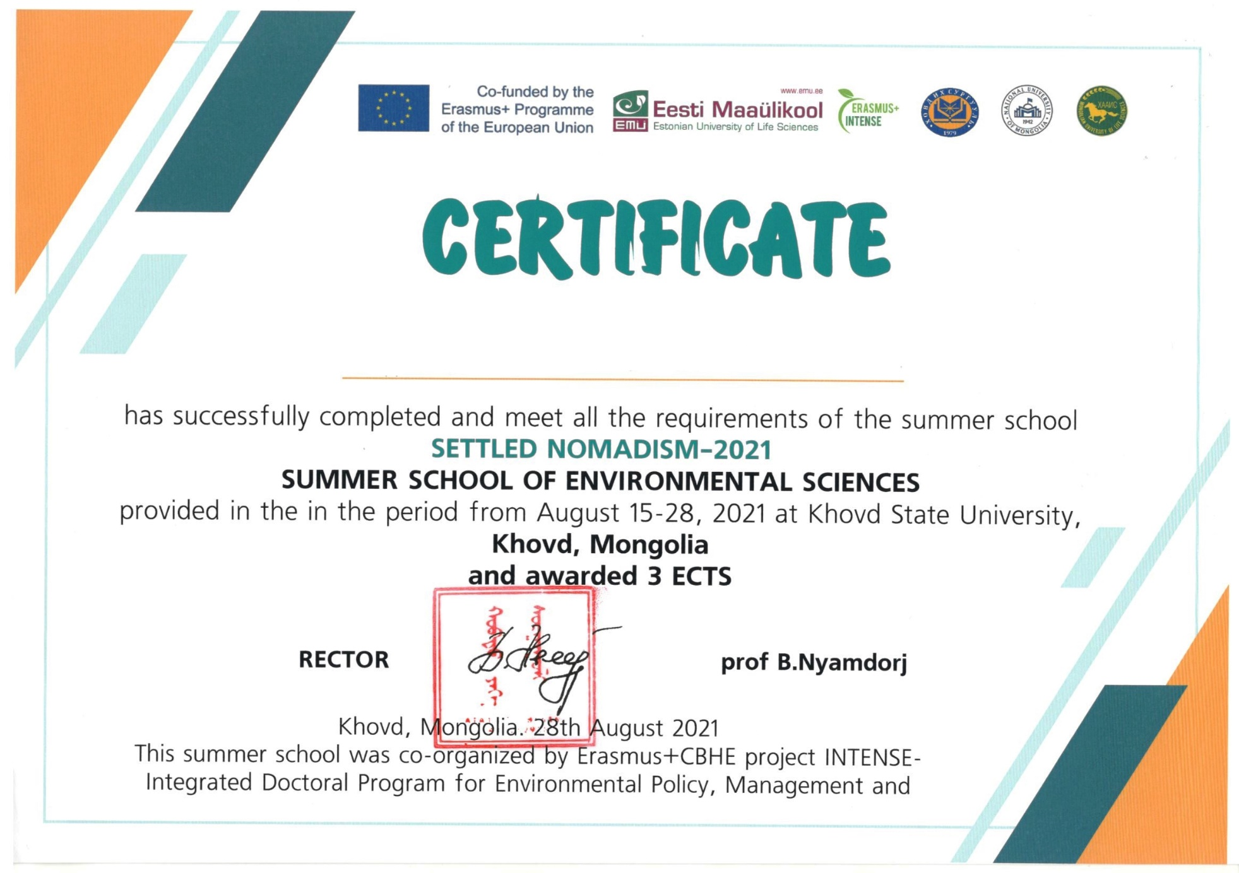

Appendix 4: The students’ impression about the summer school
