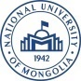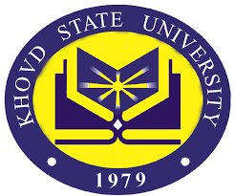

Academic staff and student training and dissemination session at National University of Mongolia (Ulaanbaatar), Mongolia

2019, September 25

The event included an open lecture of Dr. Anton Shkaruba on post-disaster governance and its discussion by academic staff and students in terms of research and policy context of Mongolia.

Although the topic is very sad in itself, giving a talk on post-Chernobyl disaster governance based on our research with Hanna Skryhan is always fun, as you never know, who is going to be your audience, and what would be its reaction. This time we had several professors involved to the national nuclear energy commission in Mongolia, teachers from National University of Mongolia covering Chernobyl in their teaching, and lots of nice students.

The audience has enjoyed the discussion - it was very well versed in the subject matter, and all the questions were amazingly relevant and to point. (Appendix 3)

List of attendees at the open lecture:
- P.Zuzaan Professor
- N.Norov Professor
- S.Davaa Professor
- S.Odmaa Associate professor
- M.Odsuren Associate professor
- G.Tamiraa Associate professor
- Ts.Togsoo Associate professor
- Master and bachelor students, in total 11 people
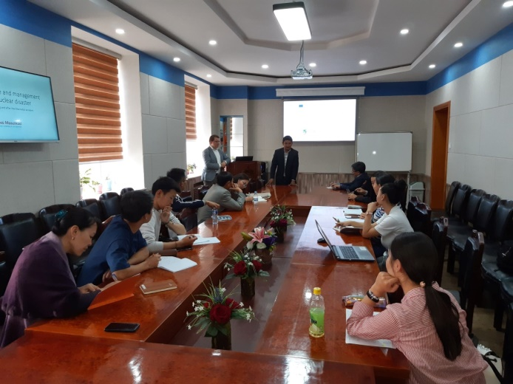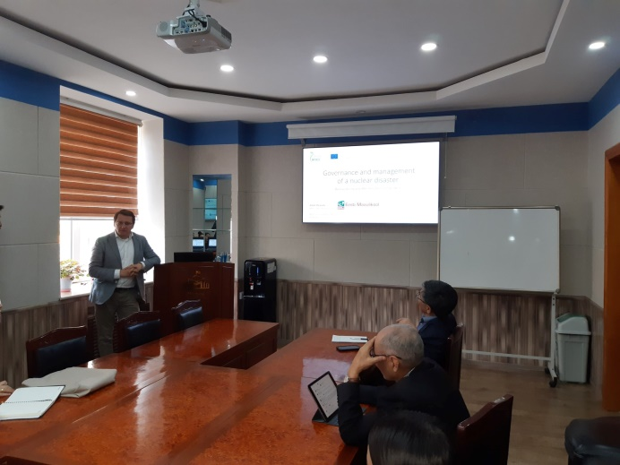

Appendix: Open lecture announcement
