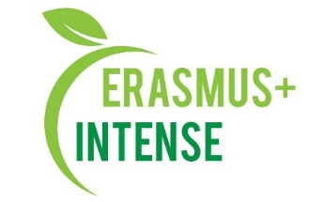

Plan for the activities of the UA National INTENSE school
for
2020 - 2021 academic year

№ п/п | Activity | Implementation period
1. | As part of educational activities, teaching disciplines for graduate students | During the year
2. | Researches by graduate students on the topics of PhD theses | June 2021
3. | Conducting scientific seminars for graduate students, masters, and staff | During the year
4. | Preparation of reviews, response to the PhD theses | During the year
5. | Defense of PhD theses for the degree of Doctor of Science (Doctor of Philosophy) | Spring semester
6. | Work on open massive online courses | During the year
7. | Drawing up, coordinating the curriculum for graduate students for the 2021-2022 academic year in specialty 103 "Earth Sciences" | Spring semester
8. | Preparation and licensing of the educational program "Earth Sciences", 103 Earth Sciences | During the year
9. | Development and signing of the Regulations of the Doctoral School | During the year
10. | Accession of new members to the Regulations of the Doctoral Program | Spring semester
11. | Finalization of academic disciplines developed within the INTENSE project | During the year
12. | Preparation of publications (abstracts of reports and articles) by participants of the Doctoral School | During the year
13. | Presentation of works on the project of International and All-Ukrainian conferences | During the year

