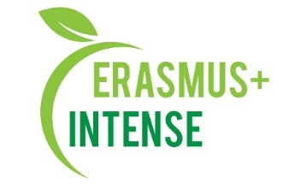

Plan for the activities of the UA National INTENSE school
for
2021 - 2022 academic year

№ п/п | Activity | Implementation period
1. | Enrollment of graduate students | September
2. | As part of educational activities, teaching disciplines for graduate students | During the year
3. | Researches by graduate students on the topics of PhD theses | September 2021
4. | Preparation of reviews, response to the PhD theses | During the year
5. | Defense of PhD theses for the degree of Doctor of Sciences | Spring semester
6. | Work on open massive online courses | Fall semester
7. | Drawing up, coordinating of the curriculum for graduate students for the 2021-2022 academic year in specialty 103 "Earth Sciences" | Spring semester
8. | Accession of new members to the Regulations of the Doctoral Program | Fall semester
9. | Lectures and scientific seminars of associate members of the INTENSE project (specialists and graduate students) | During the year
10. | Preparation of publications (abstracts of reports and articles) by participants of the Doctoral School | During the year
11. | Conducting a summer school for graduate students | Fall semester
12. | Conducting scientific seminars for BSc, MSc and PhD students and staff | During the year
13. | Conducting a series of international thematic online webinars | Fall semester
14. | Presentation of works on the project of International and All-Ukrainian conferences | During the year

